Academic Advantage

Sign Up Guide for Tutors



Updated - October 2023

Key Personnel at Academic Advantage:

Clare Shoreland - Senior Recruiter

James Farrelly - Director of Education

Harriet Pearson - Operations Manager

Contents Page

Section 1 - Creating an account 3
Section 1.1 - How do I create an account? 3
Section 1.2 - Summary of the Sign-Up process 3
Section 2 - Completing your profile 4
Section 2.1 - Navigating your profile 5
Section 2.2 - Basic details to add to your profile 5
Section 2.3 - What are my Teaching Skills and adding them to my profile? 6
Section 2.4 - Do I need to have minimum grades? 7
Section 2.5 - How do I add my qualifications? 8
Section 2.6 - How do I add the institutions I’ve attended? 8
Section 2.7 - What do I put in my Bio? 9
Section 2.8 - How do I set my availability as a Tutor? 10
Section 2.9 - How do I upload a DBS check? 11
Section 2.10 - How do I upload a Fit for Work Form 11
Section 2.11 - What next? 11
Section 3 - Tutors earnings 12
Section 3.1 - Selecting Your Tier 12
Section 3.2 - What tier do I fit into? 13
Section 3.3 - Moving Up a Tier 13
Section 3.4 - Getting More Work 13
Section 3.5 - Tier Elevation: Keeping Client Rates 14
Section 4 - Using your profile 14
Section 4.1 - Usability 14
Section 4.2 - What’s a trial session and do i have to do one? 15
Section 4.3 - How to do a trial session 16
Section 4.4 - How to accept a booking request 16
Section 4.5 - How to join a session 17
Section 4.6 - How does a tutoring session work? 18
Section 4.7 - How to organise a repeat lesson 20
Section 4.8 - Cancelling a Lesson 21
Section 4.9 - How to invoice a client? 21
Section 4.10 - What’s a lesson report card? 22
Section 5 - Accounting 22
Section 5.1 - How do I set up a payout account with Stripe? 22
Section 5.2 - How long until I receive payment after a session? 23
Section 5.3 - What’s a chargeback and how do I deal with it? 24
Section 6 - Requesting a DBS check 25
Section 6.1 - How do I request a DBS check from the Government? 25
Section 6.2 - How to request a DBS another way 25
Section 7 - Additional Support 26
Section 7.1 - What do I need to do before a session? 26
Section 7.2 - Where can I complete a session? 26
Section 7.3 - Sending additional learning materials or links 27
Section 7.4 - Where do Academic Advantage fees go? 27
Section 7.5 - Who can I contact for further support? 28

Section 1 - Creating an account

Section 1.1 - How do I create an account?

If you haven’t already, create an account with Academic Advantage by clicking the link below:
https://secure.tutorcruncher.com/academic-advantage/signup/tutor/
You can sign up through google or facebook, or enter your details as requested. This will take you to our online platform where you can create your profile and upload the relevant documentation. 💼
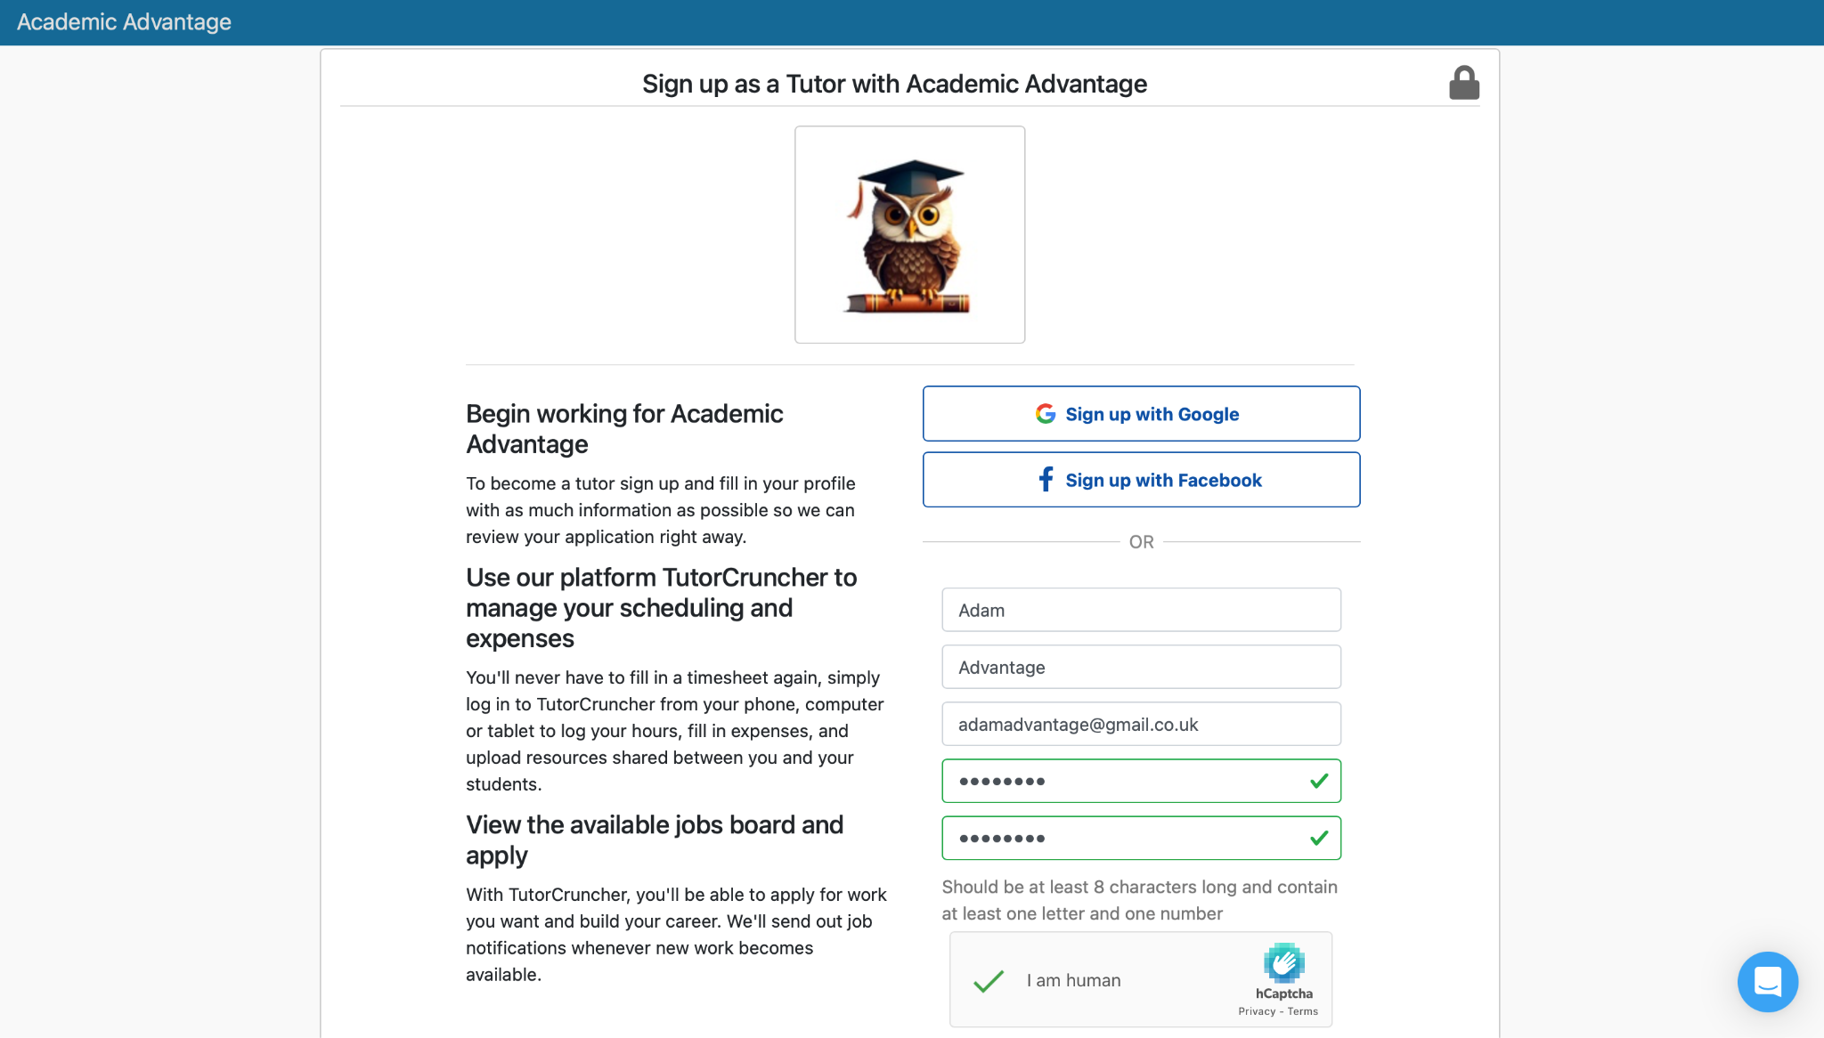

Section 1.2 - Summary of the Sign-Up process

To sign up and become a successful tutor with Academic Advantage you’ll need a few things, these are as follows:

Firstly sign up as a tutor using the link provided above, we will then ask you to outline your educational background and teaching qualifications.

We find the higher the grades, greater tutoring experience, and reviews, the more you can earn as a tutor, it's in your best interest to show off as much as possible on your profile. 🎓

Specify your qualifications, for example how many GCSE’s do you have? What levels did you achieve? Add these things to your profile in as much detail as possible. To go above and beyond you can even provide a description of your tutoring techniques and what makes you stand out compared to other tutors. ✏️

You’ll be ready to go after submitting an up-to-date CV, your DBS, proof of qualifications and any other documentation you think would help. An admin will then contact you to arrange a short interview to make sure you fit Academic Advantages requirements and vice versa. 👩‍💼

Section 2 - Completing your profile

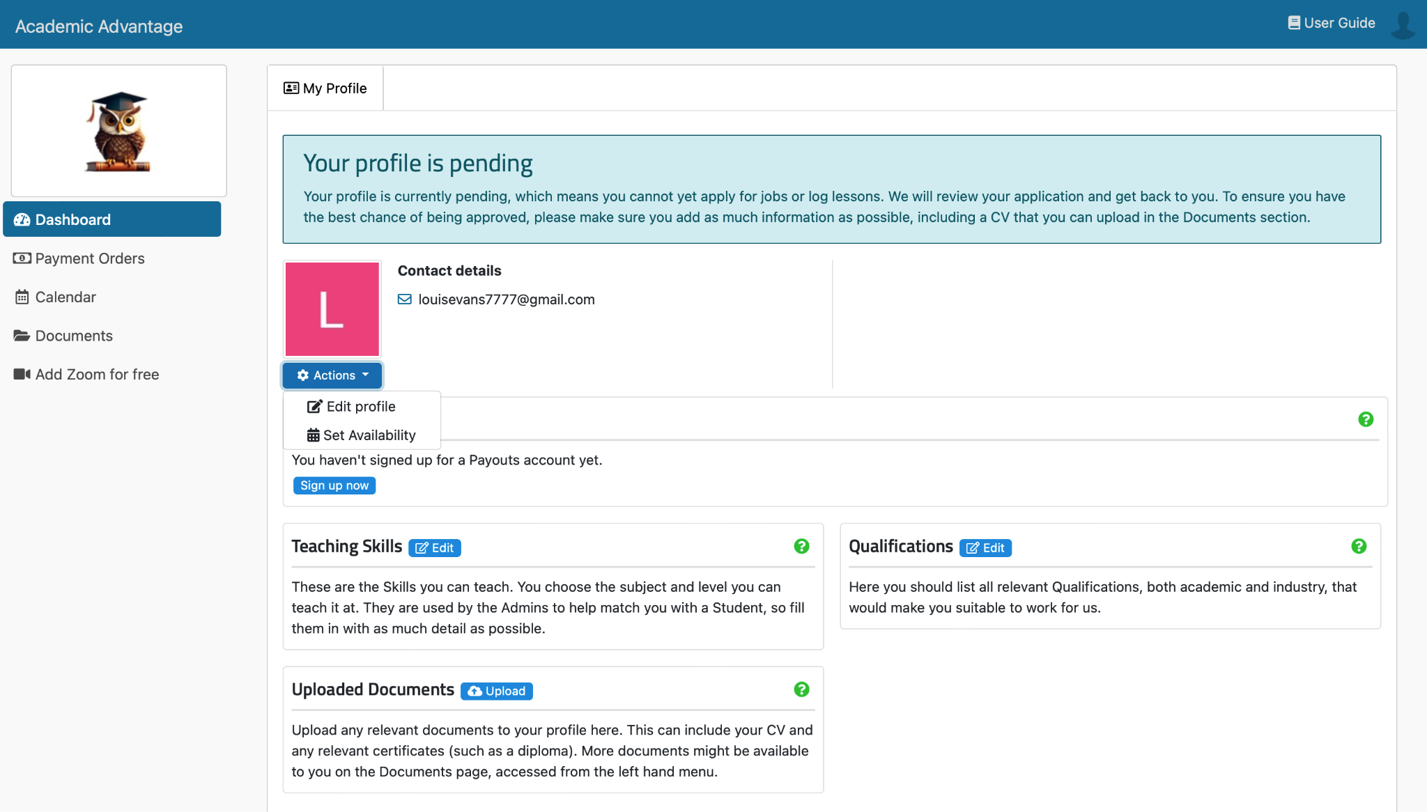
When you log into your Academic Advantage account, the first thing you'll see is your dashboard. Here you'll be able to see all of the information that's relevant to you at a glance. 👩‍🏫

Section 2.1 - Navigating your profile

The dashboard allows you to access all the information relevant to you during the sign up stage of becoming a tutor. Until you have completely signed up and been approved by an admin your dashboard will be restricted.

You’ll be required to edit all the information about your teaching skills, qualifications, and any documents. You can also set your availability and edit more about your profile through the blue action button. ⚙️

Section 2.2 - Basic details to add to your profile

Please ensure that your bio encompasses all aspects about you. This can include your qualifications, accomplishments and anything interesting about you.

We encourage you to be comprehensive, particularly as a tutor, as this is an opportunity to showcase your extensive experience and credentials through your profile. 👨‍🏫

Make sure to set a profile picture on your profile, remember, this is the first thing that a Client will see when they click your profile, you want to make it as professional as possible. We love a funny profile picture but sometimes it can be a bit too much. Treat your profile picture a bit like your linkedin photo but with a smile. 😁


The image to the left is a perfect example of what we think a great profile picture should look like for your account.

Section 2.3 - What are my Teaching Skills and adding them to my profile?

These are the subjects or otherwise known as skills you can teach. To add or edit skills, click on the edit symbol next to teaching skills. Select a subject and the levels you can teach it at, add another if necessary, and click submit when you are done. ✏️

If you can teach a subject/skill but can’t find it on the list, send info@academicadvantage.co.uk an email and ask us to add a custom subject. We’re always keen to broaden our subject choice offerings. 🔎

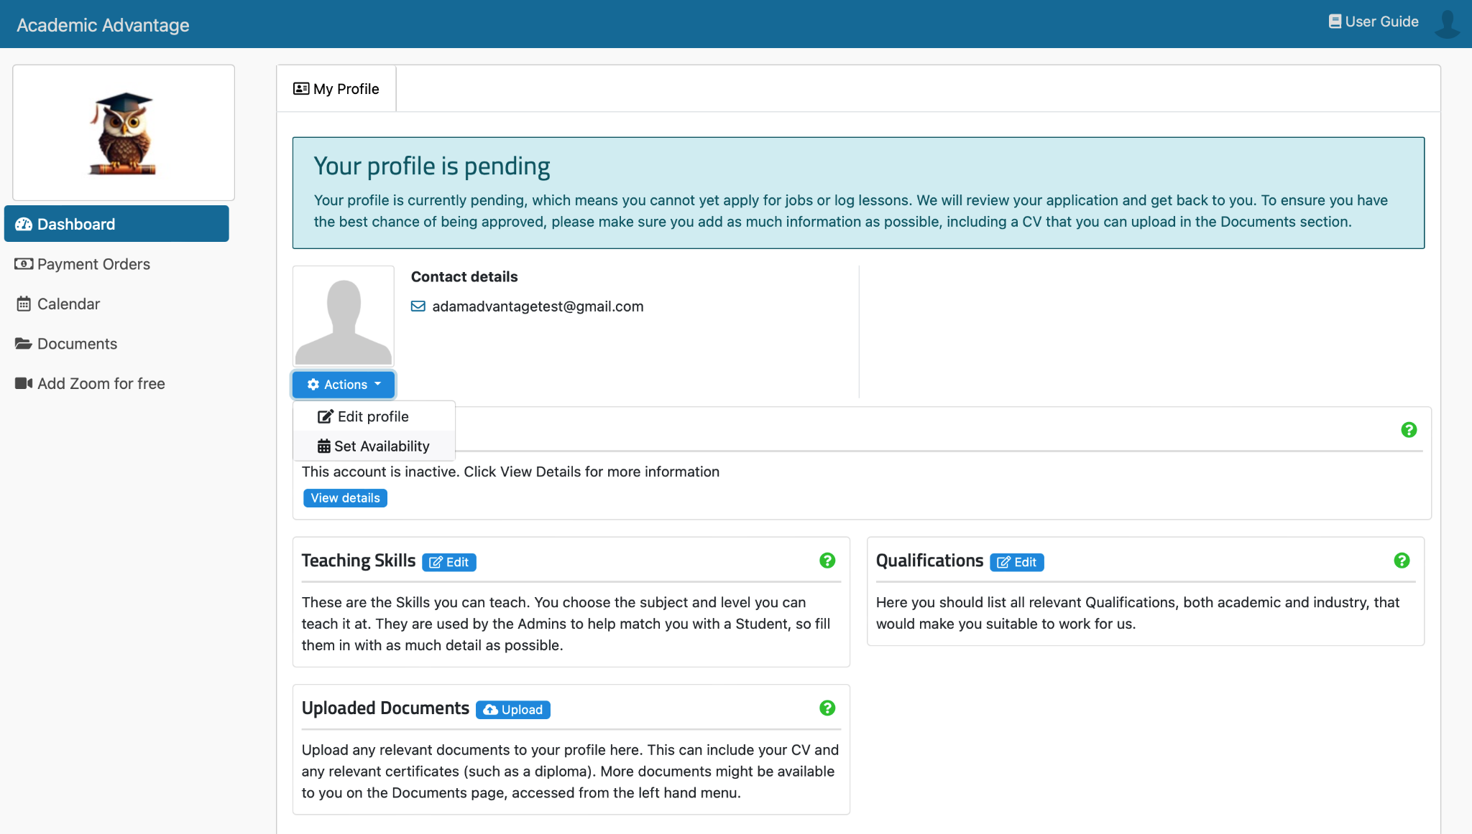

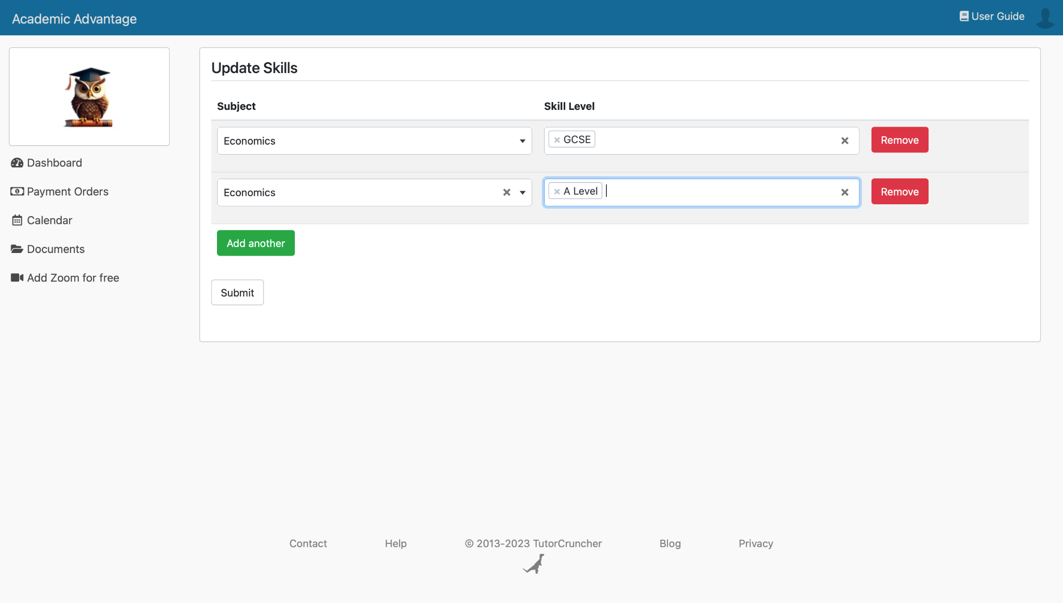

Section 2.4 - Do I need to have minimum grades?

You’ll need a minimum B Grade at A-Level in order to teach a subject at GCSE and a minimum A Grade at A-Level to teach that subject at A-Level.

So you want to teach at this level? | Well you’ll need to have
KS2 | A-Level / IB / Equivalent ( B / 6 or higher)
11+ | Sat the 11+ yourself
KS3 / GCSE | A-Level / IB / Equivalent ( A / 7 or higher)
A-level / IB / Scottish Highers | Forms a major part of your degree AND with an A at A-level / equivalent or higher
University | Degree level

Please note that you’ll still need these grades to tutor language subjects, even if you’re a native speaker!

Section 2.5 - How do I add my qualifications?

This is the place to list all relevant qualifications, both academic and industry if possible, that would make you suitable to work for the company. 🧑‍🏫

To add a qualification, click on the plus symbol, enter the relevant information, and click submit. If you require additional qualification levels, not on the list, ask us via email to create the required custom qualification levels. 🎓

Section 2.6 - How do I add the institutions I’ve attended?

Institutions show where you received your qualifications. Other notable institutions you attended but didn't get qualifications from can also be included. If there is an institution that you would like to add but is not in the list, you can add it by going to add institution and then add custom institution. 🏫

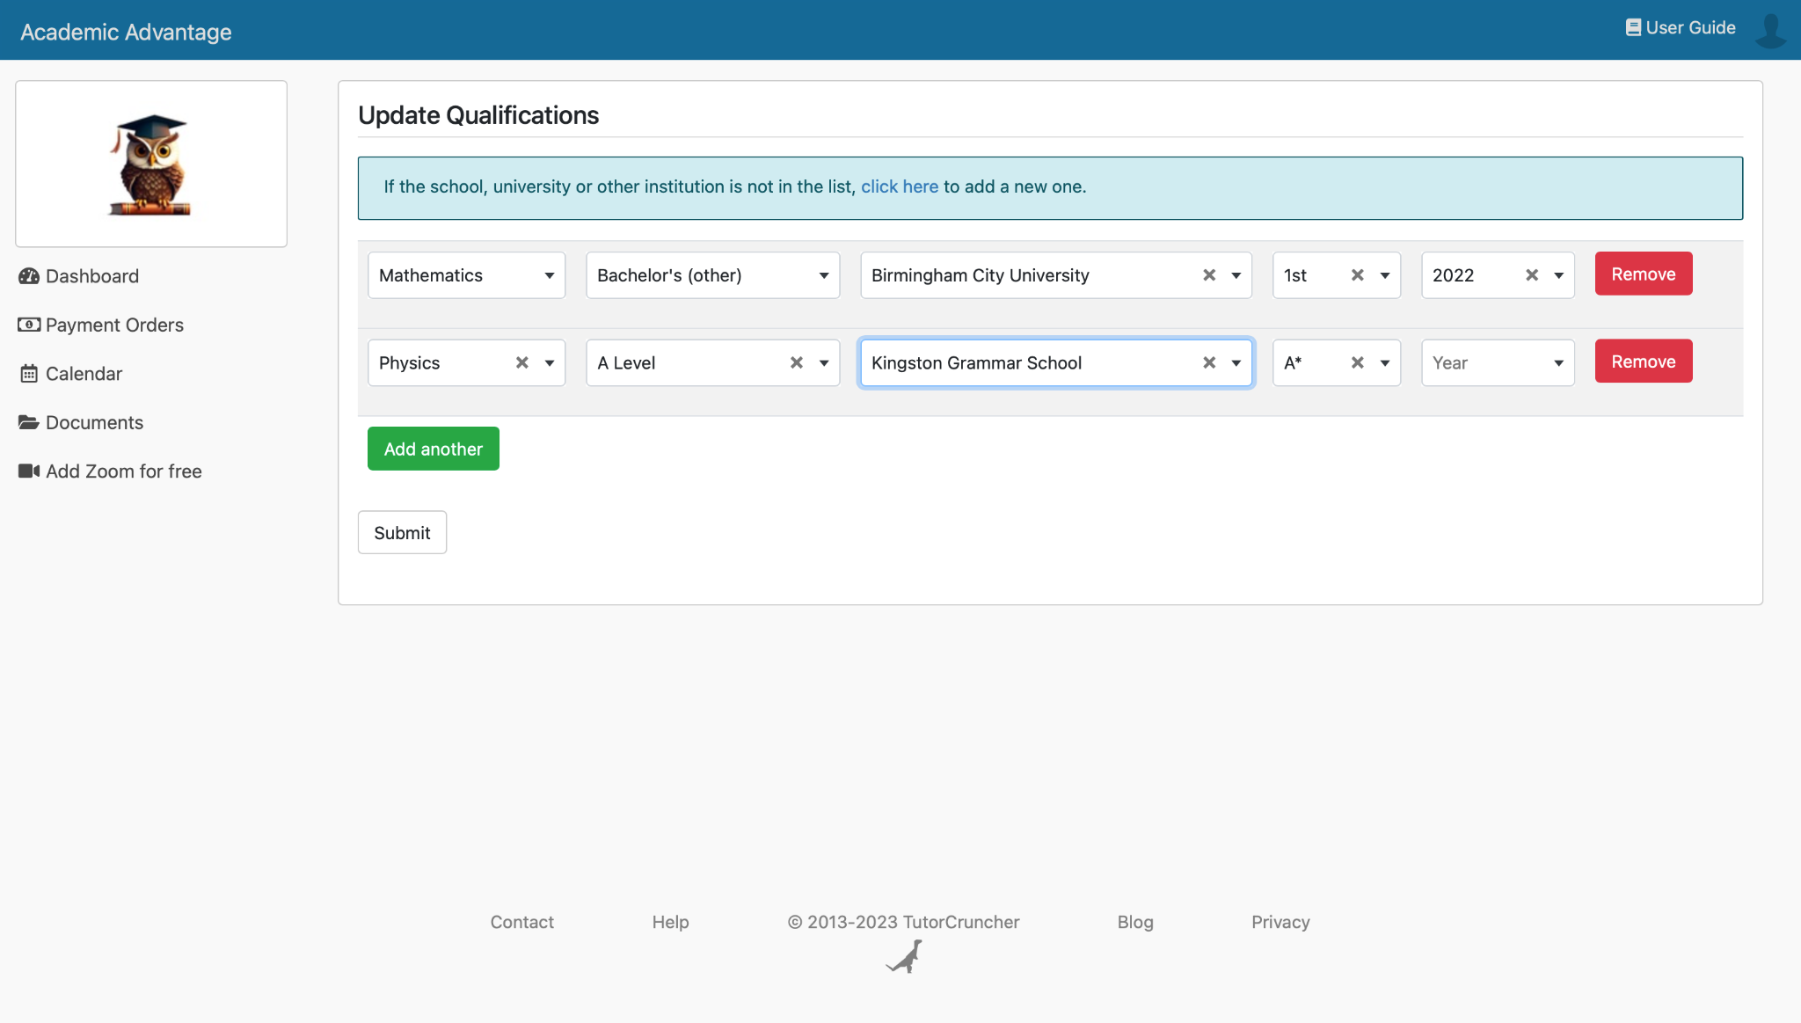

Section 2.7 - What do I put in my Bio?

Click edit profile where you will be taken to a page which allows you to write a bio and enter your teaching experience, below is an example of this. Be professional, but most importantly be yourself and be unique! 🤠

An example from one of our most popular tutors is the below:

“Hi, my name is Issy! I’m a fun, enthusiastic teacher who would love to have the pleasure of sharing my passion of learning and teaching Maths and French with you! Out of the classroom I love to read, walk, listen to podcasts and play lacrosse”. 🥍

“I originally trained as a primary school teacher after my maths degree from Nottingham, after obtaining my qualified teacher status I decided I wanted to teach at GCSE level, I now currently teach hundreds of children at a local Grammar School and do private tuition on the side”.

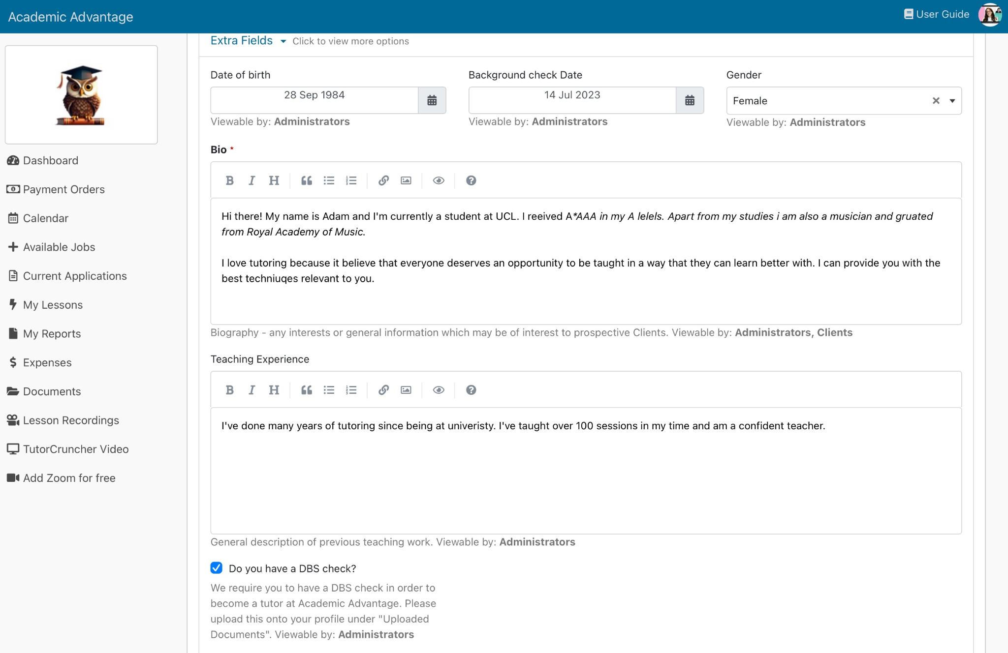

Section 2.8 - How do I set my availability as a Tutor?

Employment with Academic Advantage offers unparalleled flexibility. 💪

Make sure to set your availability as a tutor in your dashboard under my profile ↪️ actions ↪️ set availability. This will enable clients to request to book a lesson with you.

Select the available start and end times, then click the dates on the calendar where applicable, and click save. Alternatively, you can create availability for several dates at once by clicking the mass create button and filling in the details. 🗓️

Choose as many, or as little hours as you please. 😃

Section 2.9 - How do I upload a DBS check?

If you do not yet have a DBS check please head to section 5. This is an extremely important part of the sign up process that can’t be missed. To upload your DBS check head over to upload documents on the dashboard.

Along with your DBS upload you will also need to provide a proof of address in the form of a driver's licence, utilities bill, or bank statement. 🕵️
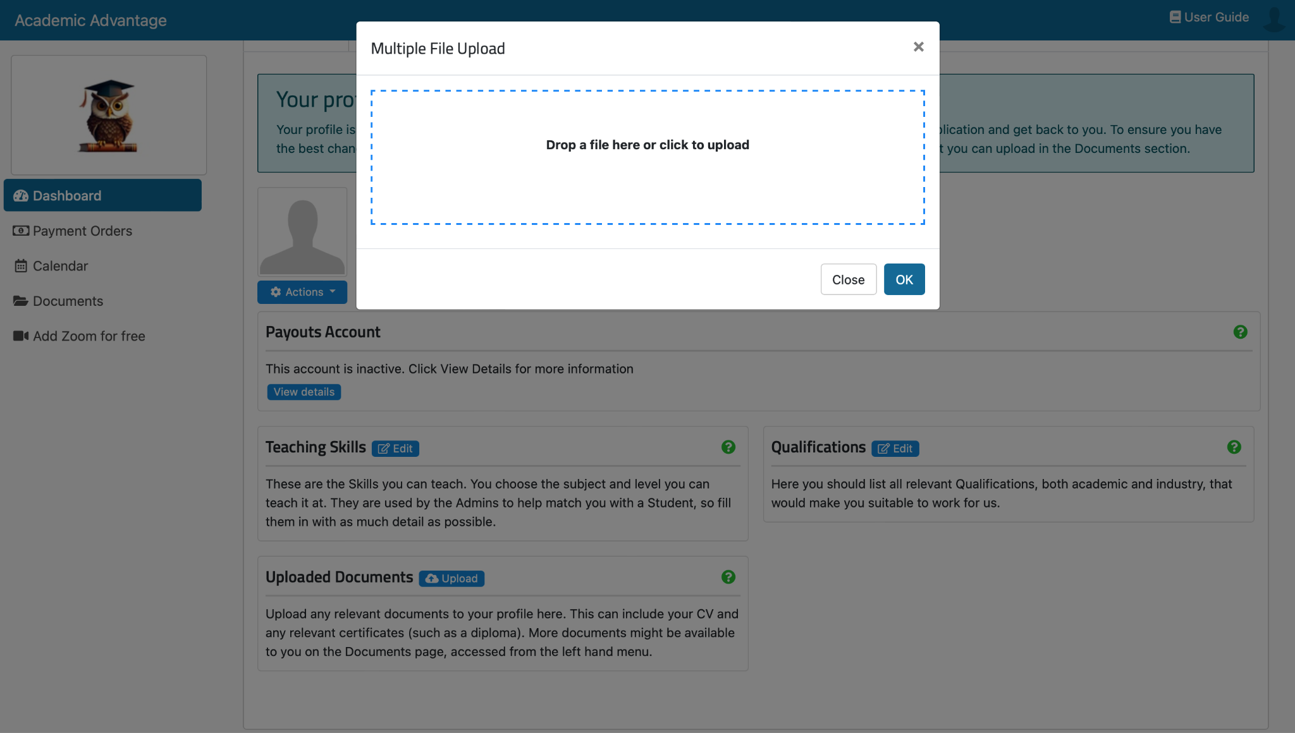

Section 2.10 - How do I upload a Fit for Work Form

If you have not been given a fit for work form yet you will need to request one and fill it out. Please contact info@academicadvantage.co.uk for a copy of one, alternatively contact Claire Shoreland on Linkedin and she will supply one to you. 🫡

Section 2.11 - What next?

Once you have followed all the instructions within section 2 the next step is to wait. A member of the Academic Advantage team will review your profile. You will be contacted via email on your outcome, or if we need extra information. 📧

Section 3 - Tutors earnings

Section 3.1 - Selecting Your Tier

As a Tutor at Academic Advantage you have the ability to set your own tutoring fee, you can choose from our five tiers, which will dictate how much you get paid. 💰

It’s worth keeping in mind that Clients will be more willing to pay based on your academic qualifications and achievements, experience, and reviews.🌟

Why do we structure Tutors into categories? Our aim is to:
- Set your pay 💵
- Diverse tutor selection for clients 📚
- Competitive marketplace variety 📈
- Personalised comfort at your level 💆

Below is our Tutors pay guide, here you can take a look at what we think is appropriate for a Tutor depending on their level of experience.

Tier | Lessons Required | Tutor’s Fee (What a Tutor actually earns)
Tier | Lessons Required | GCSE | A-Level | University
Platinum | 201+ | 40.00 | 40.00 | 50.00
Diamond | 151-200 | 29.00 | 29.00 | 32.00
Gold | 101-150 | 19.00 | 20.00 | 21.00
Silver | 10-100 | 16.00 | 16.00 | 17.00
Bronze | 0-10 | 12.00 | 13.00 | 14.00

Section 3.2 - What tier do I fit into?

So you’re wondering what tier you fit into? Well take a look at the below table, this should help give you a guide on what we find Tutors are able to charge depending on their experience, qualifications and reviews.

Tier | Qualification Expectations
Platinum | Very experienced Tutor / Russell Group University / QTS / A* or 9 in subject area
Diamond | Experienced Tutor / Russell Group University / All A's and some A*s or 8s
Gold | Experienced Tutor / A+ Grade student and University background
Silver | Intermediate Tutor / A Grade student with University background
Bronze | New Tutor / B + Grades at GCSE and A-Level

Section 3.3 - Moving Up a Tier
Once you’ve selected your tier during the interview stage, the only way to change your tier is to email info@academicadvantage.co.uk

Bookings made prior to your tier adjustment will retain their original price. ❌

Section 3.4 - Getting More Work
A few tips to help you pick up some extra lessons: 💡

- A high quality photo - We recommend that you upload a well-lit, high quality photo that is taken of just yourself. 📸

- The amount of subjects - Keep in mind that the subjects you offer can impact the number of profile views you get - if you teach popular subjects like Maths and Science, you’re likely to have more profile views than nicher subjects. 📚

- Being Punctual - Make sure you’re turning up for lessons on time and not leaving early. Be quick to respond to jobs and to complete lesson reports! ⏰

- Clear Profile - Your profile should give students a good sense of who you are and your teaching style. This is your opportunity to share your passion for your subject(s) and for tutoring, and let parents and students know what your lessons might be like. 📋
Consider including the following:

- Tutoring Experience
- The University you’re at (or were at)
- Hobbies or interests
- Teaching styles and techniques

Do not include any contact information. ⚠️

Section 3.5 - Tier Elevation: Keeping Client Rates
If you’re considering moving up a tier, you may want to keep existing clients on your old band to ensure they continue booking sessions with you. 🤝
When you request to move up a band you will be asked in a response email if you want to keep any clients on your old rate. We will handle this process for you. 😁

Note: If you wish to discuss a potential price increase or maintain your clients rate at the same level, please do so with the paying party after the session in the video call.

Section 4 - Using your profile

Section 4.1 - Usability

Once you’ve been accepted as a tutor you will have full access to our platform. 🥳.

Dashboard
The dashboard will now show your upcoming and previous lessons and actions required. You will also see the amount of students you have worked with and hours you've taught, the amount you've been paid, and the amount due to you over the last 60 days. 💰

Overview
You can now also view your own analytics, so you'll be able to see your performance over time with Academic Advantage. The “Overview” section contains two separate graphs relating to hours taught & amount paid, allowing you to analyse your own performance over time. 📈

My Profile
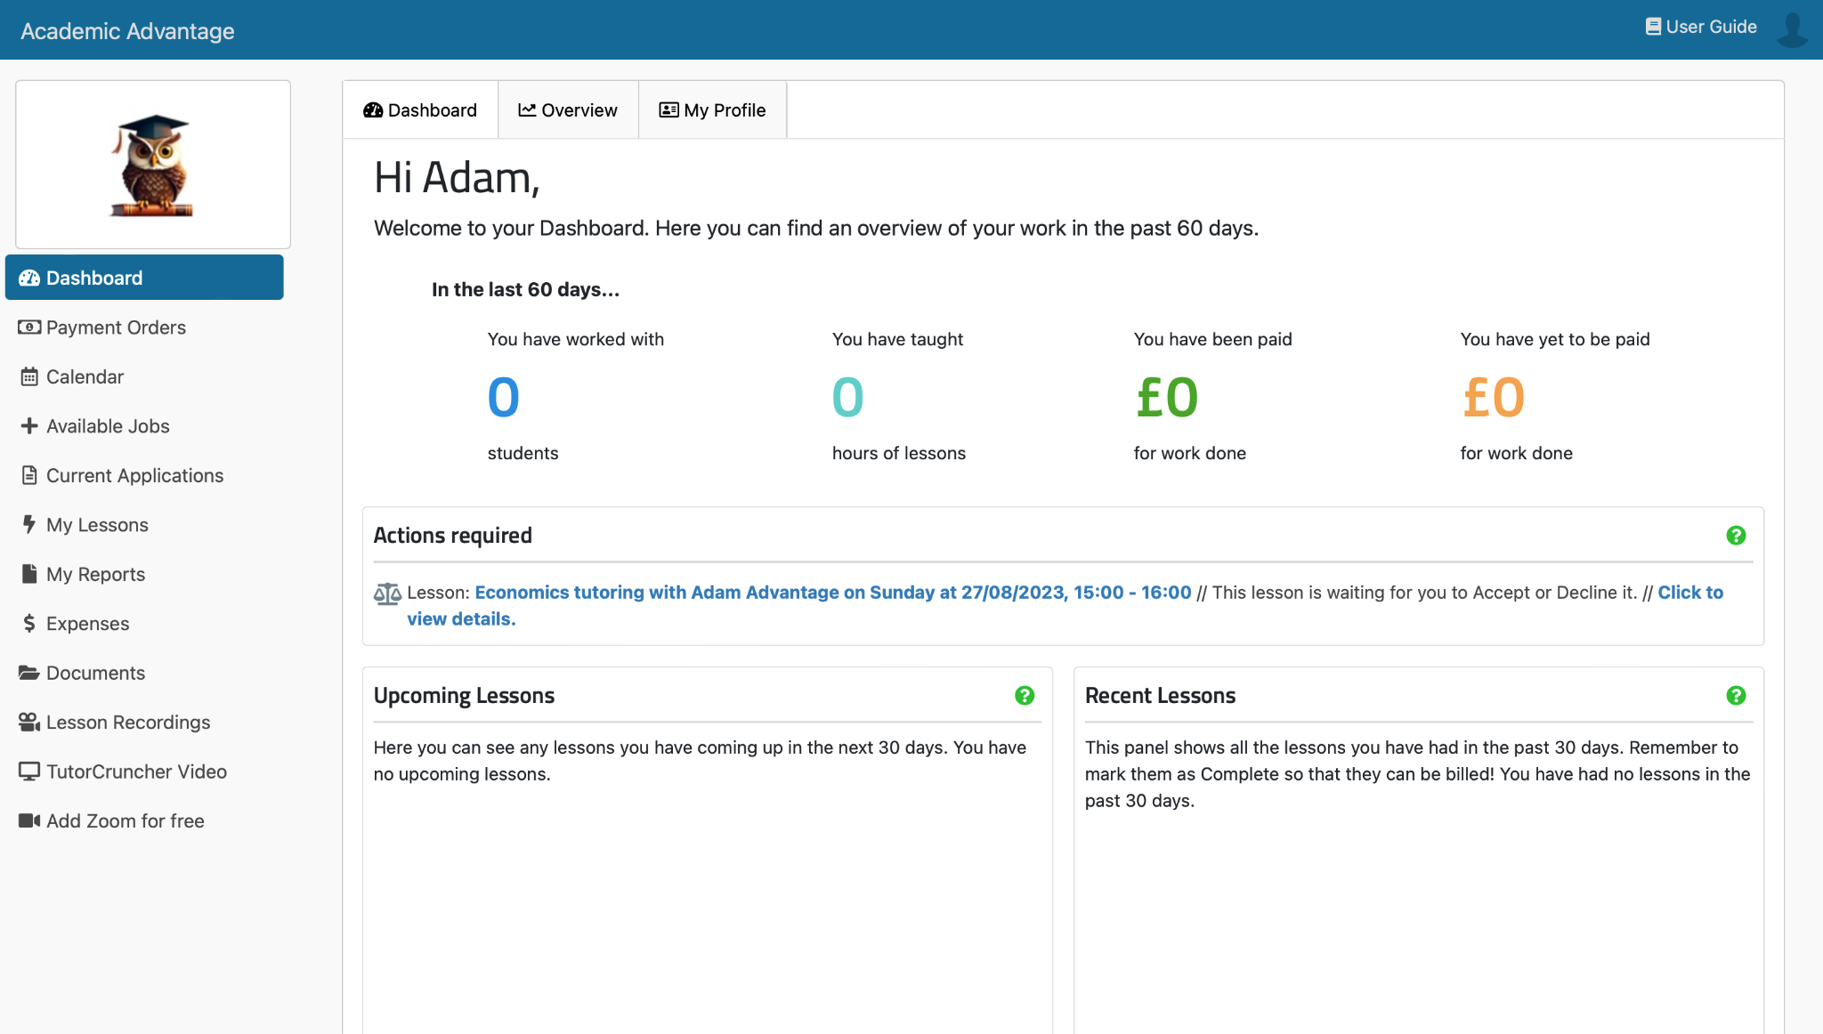
You can easily update your teaching skills, qualifications, and documents anytime. This is useful if you gain new qualifications, an improved background check, or teaching certification while tutoring. This can be done using the blue action button. ⚙️

Section 4.2 - What’s a trial session and do i have to do one?

A trial session is a quick free consultation between you and a new client in order to get to know them, and understand their needs. This session will only last a maximum of 15 minutes, but in most cases it is shorter than this. Be prepared to speak to both the parent and student, and make sure to be professional! 👔

Trial sessions are mandatory to do, as it confirms that the client is happy with you to be their tutor! This leads to securing repeat loyal customers! 😁

Section 4.3 - How to do a trial session
The best way to approach a trial session is by being yourself, but make sure to have a rough structure as suggested below:
Start off by introducing yourself, and by asking friendly questions to make your student and parent feel comfortable. It is crucial to get to know what the student is wanting out of being tutored. Here are some tips:

- Discuss the students' learning goals - It is suggested to go through the syllabus with the student to see what most needs improving on.

- Assessment - If applicable, conducting a brief assessment to gain an insight on the students current knowledge is also a good way to identify areas of improvement.

- Discuss Learning Preferences - discuss what type of learning methods best suit your student. eg. visual, auditory, kinesthetic learning

At the end of the trial session, encourage both the student and the parent to provide feedback, and ask if they would like to continue tutoring with you if you like. 🤠

Section 4.4 - How to accept a booking request

A Client can either choose to invite you to a trial session as previously mentioned in section 3.2 or they can go ahead and book with you straight away. When a Client decides to book with a tutor it will be displayed within the action required on the dashboard.

It is then up to you to either accept or decline the booking. The faster you’re able to reach a decision the better as a Client may begin to look elsewhere. ⚡
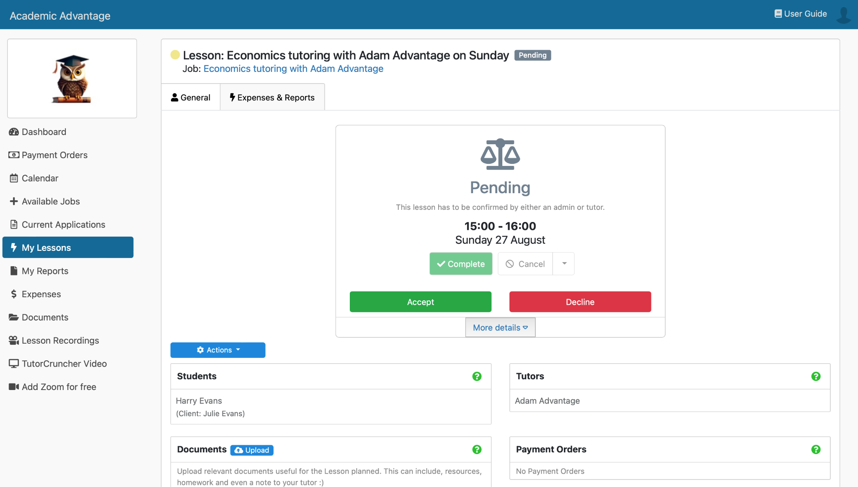

Section 4.5 - How to join a session

Once you have accepted a lesson request you will see an option under more details to join the lesson with tutor cruncher video. This is where we suggest you join your lesson 5 minutes before it starts.
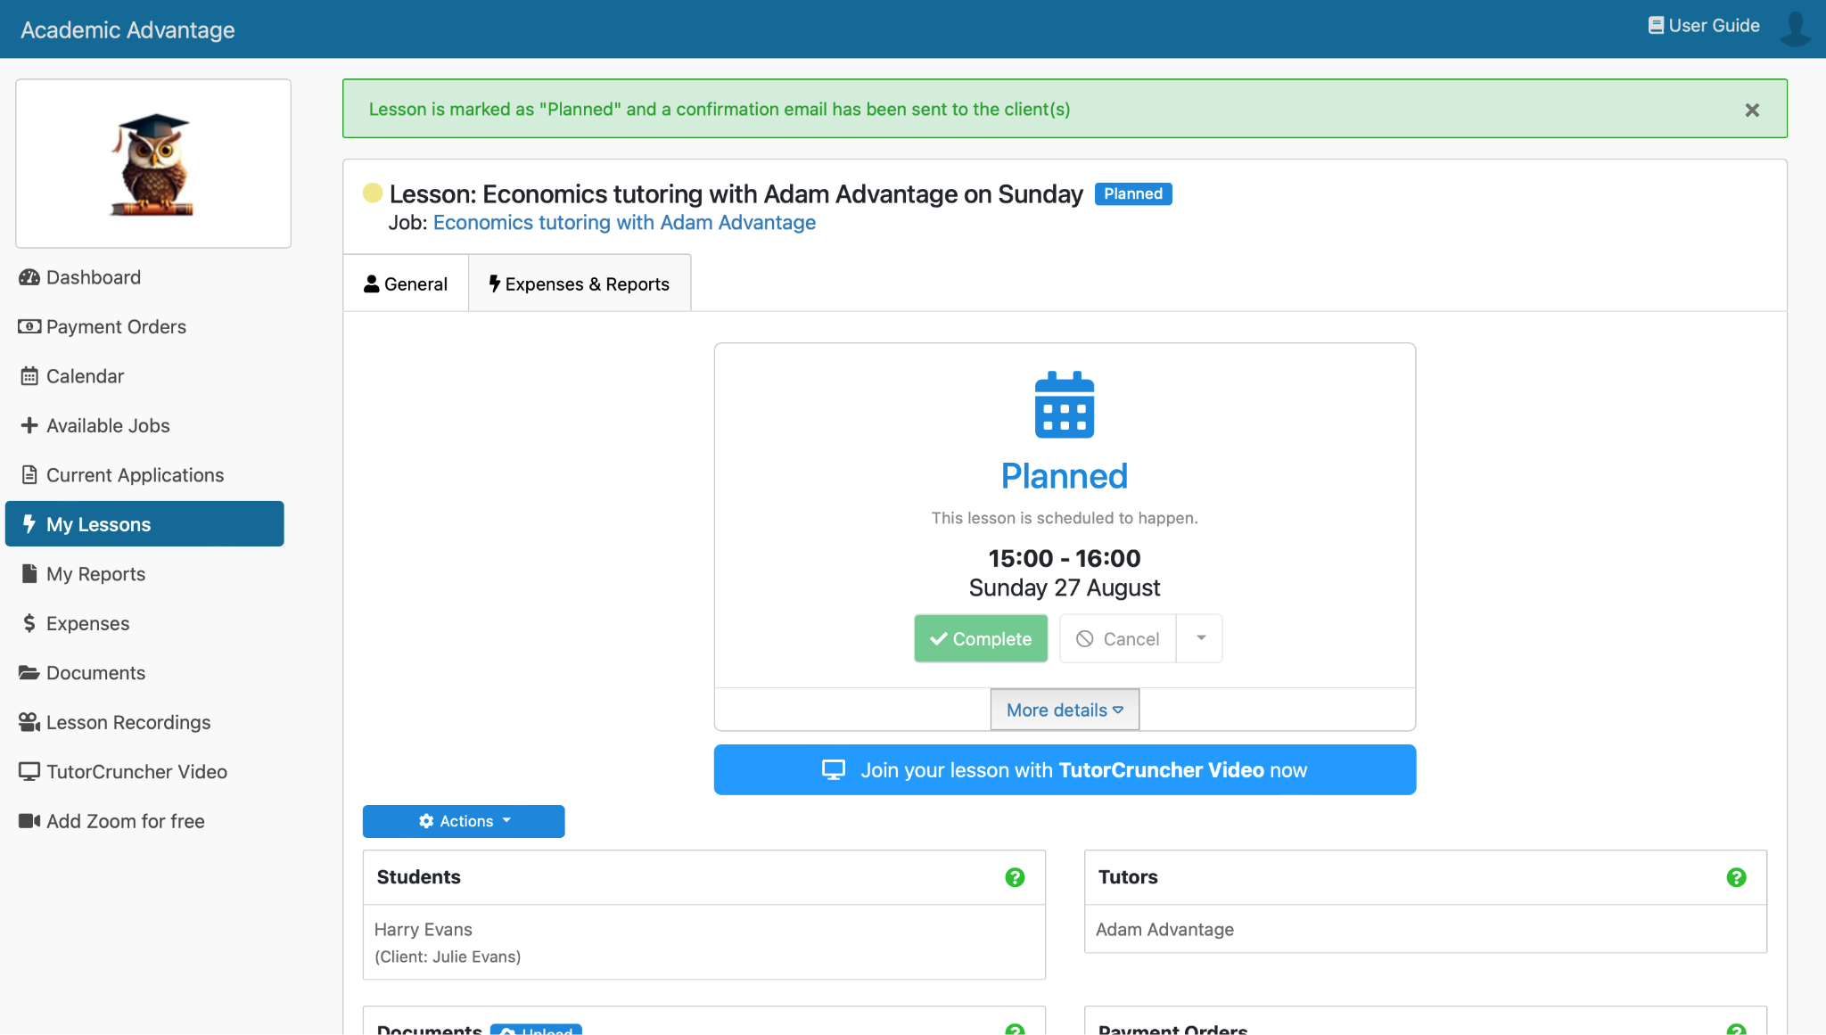

Section 4.6 - How does a tutoring session work?

Once you’ve clicked on join your lesson, you'll be asked to allow access to your camera and microphone, click yes and make sure both of these are working within the 5 minutes before your lesson starts. 🎤

Note: Make sure you enter your name so it’s not displayed as a guest!

In the bottom bar, you can access the camera, mute, view the students in your room, access chat, and share your screen! 🖥️

You can access the settings in the top left hand corner using the cog button to change your microphone and more. ⚙️
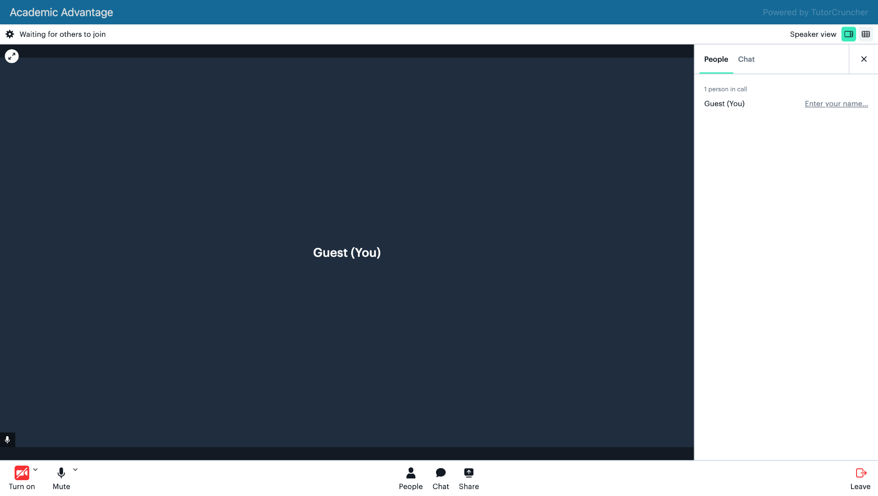
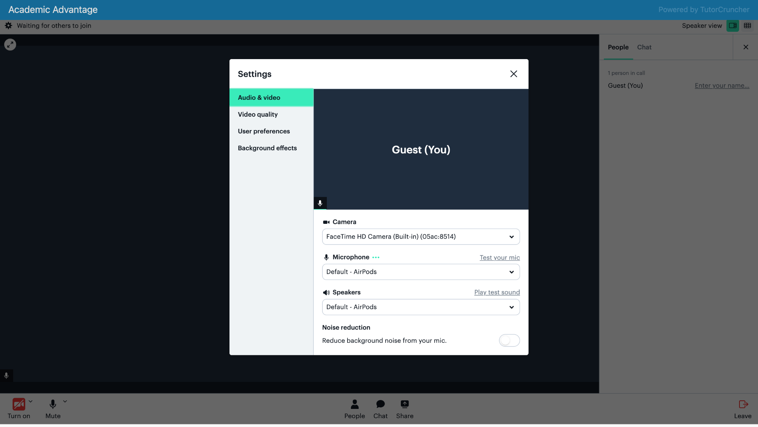

Section 4.7 - How to organise a repeat lesson
After completing your first tutoring lesson with a new Client they may have decided they would like a repeat session. To do this head to your lesson and click the blue action button giving you the option to either add a new lesson or to set up repeat lessons. 🗓
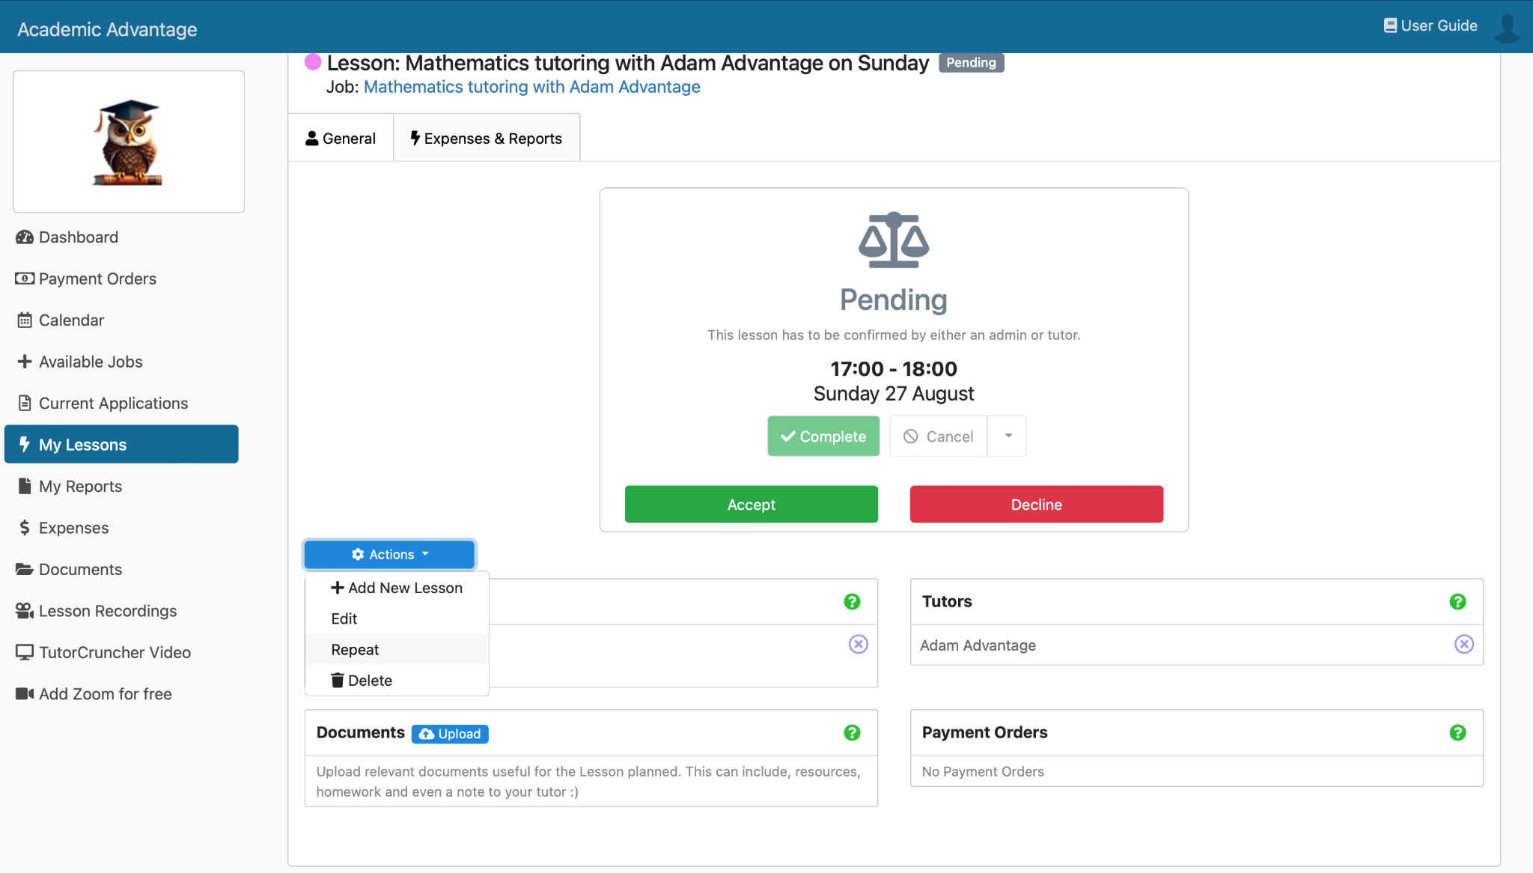
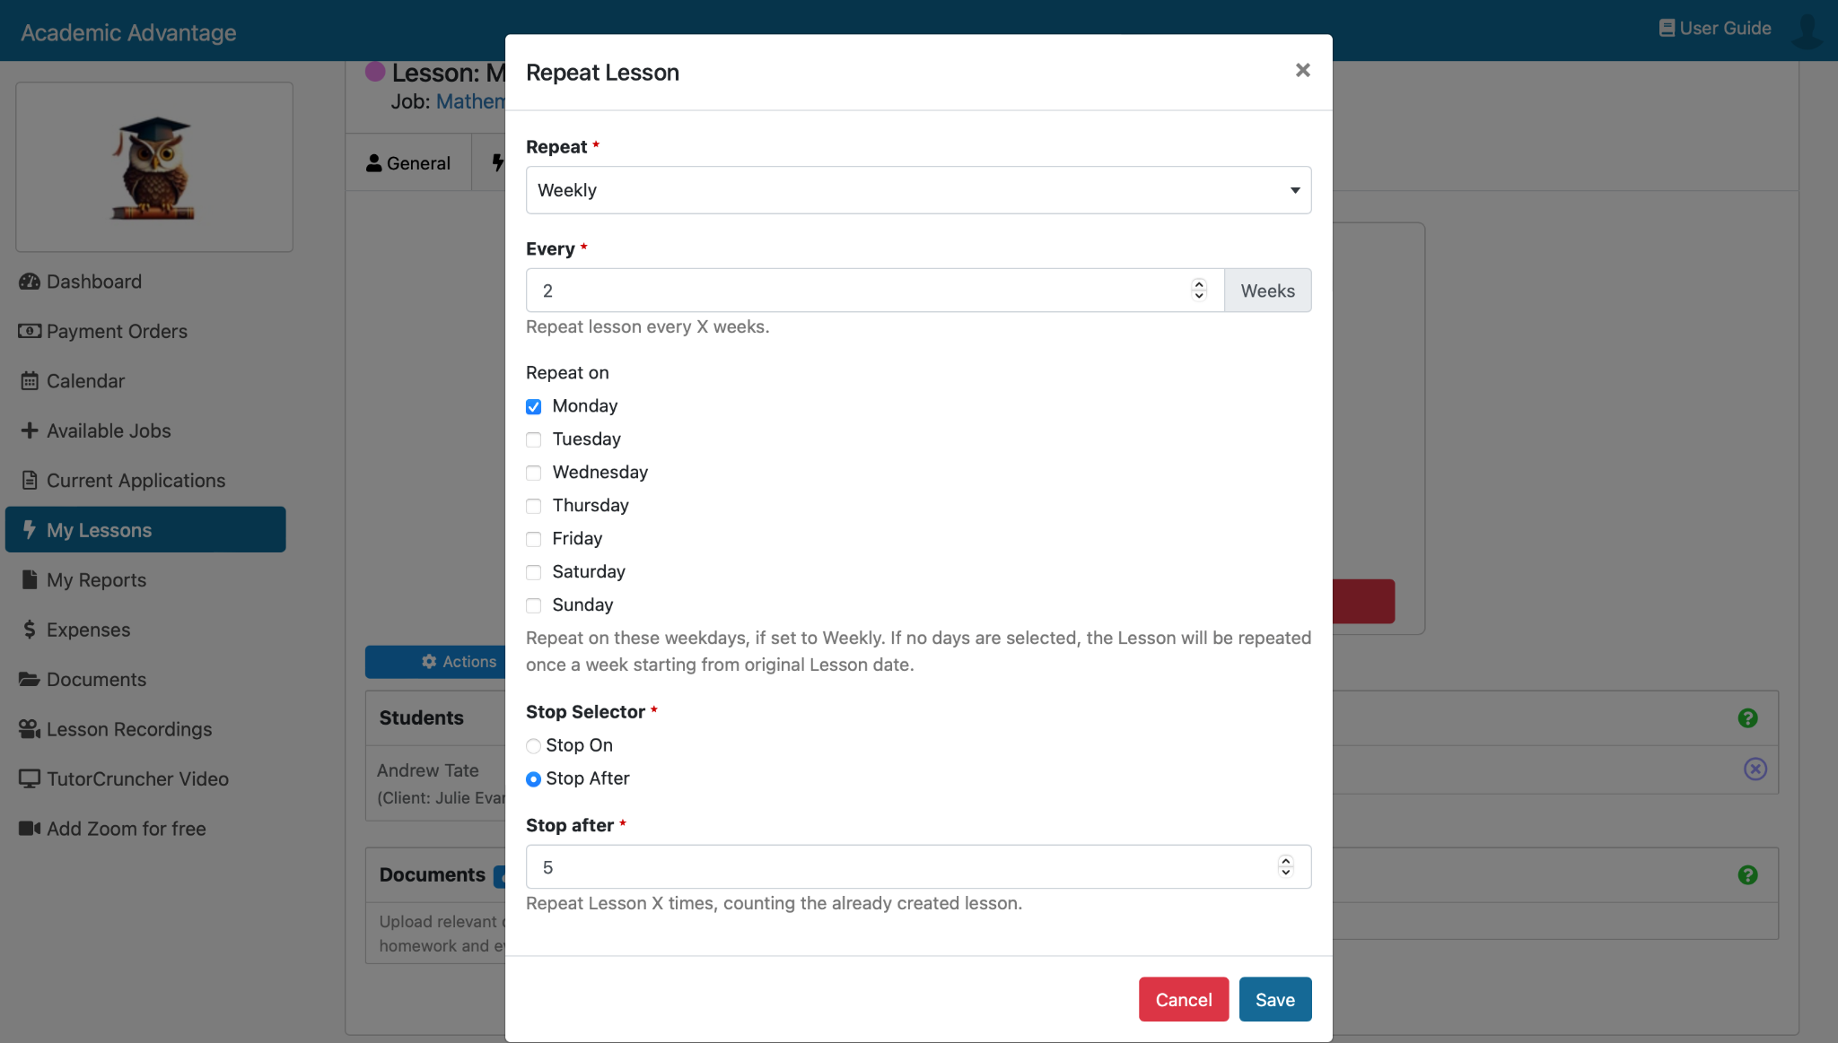

Section 4.8 - Cancelling a Lesson

If you can't attend a lesson due to unforeseen circumstances after previously agreeing to the lesson, you can cancel by pressing the cancel button. You will then be able to provide a reason. Consider including details on when you’re next available! 🗓️
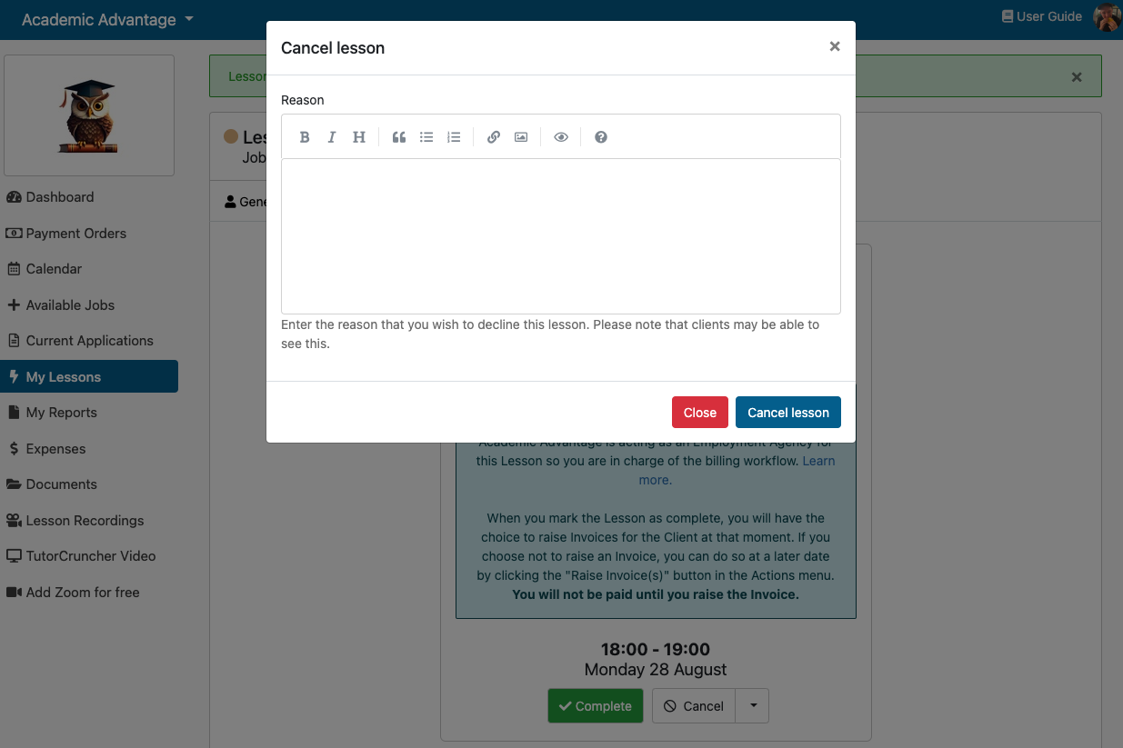

Section 4.9 - How to invoice a client?

Once a lesson has been completed an invoice will automatically be raised to the Client who will have seven days to pay. 💳

Section 4.10 - What’s a lesson report card?

After successfully completing the lesson by clicking the complete button, you will be automatically promoted to fill out a lesson report for your client. ✍️

Be sure to include all the necessary information so that parents and students can understand exactly what was accomplished during the session and what can be worked on for improvement next time. Make sure to address engagement, progress made and also the level of attainment achieved in the session. 🚀

You can access any lesson reports that have been created for your lessons by going to the specific lesson in mind, expenses and reports.

If you have marked a lesson as Complete but haven't written yet, click the + Create option.

Section 5 - Accounting

Section 5.1 - How do I set up a payout account with Stripe?

In order for Academic Advantage to pay you as the Tutor, Tutors will need to sign up for a Payouts Account. This can be done by navigating to your dashboard ↪️ profile ↪️payout account ↪️ sign up now. You will then be redirected to our Stripe sign up page. 💳

Here you will sign up, giving your details, verifying your phone number, selecting individual / sole trader’ as type of business, provide personal details, select other educational services for industry when asked, then add tutoring in the product description, provide your bank details and finally your account is created.
Voilà, you’re ready to be paid! 🤩

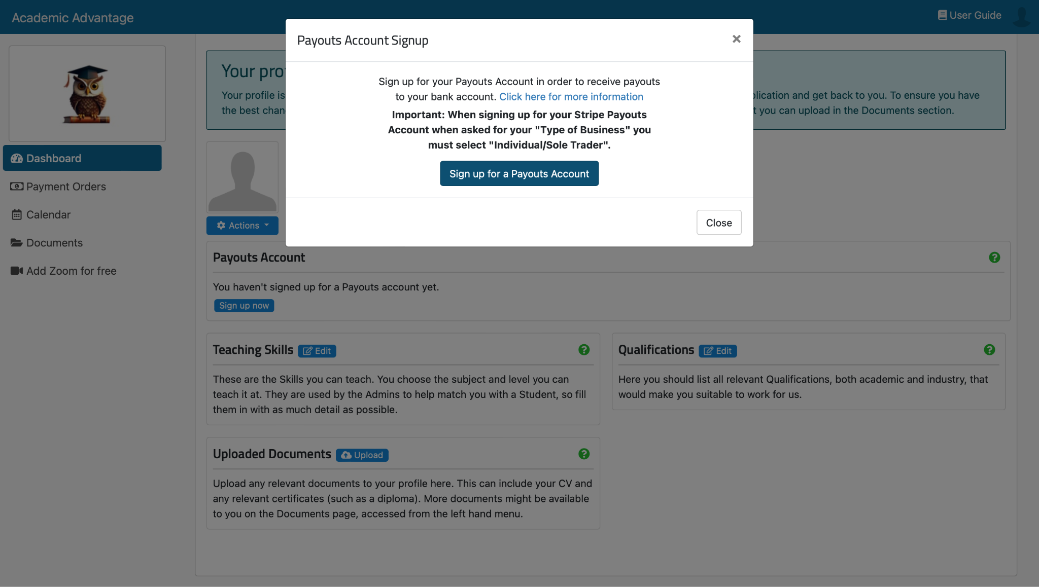

Section 5.2 - How long until I receive payment after a session?

There are 3 stages to the process in receiving funds to your bank account.

Stage 1

The client pays for their service. The money will then transfer to your Stripe account in 7 calendar days. 💳

Stage 2

The funds are in the tutor's Stripe account and will be automatically paid out at the next payout date. By default this is on the last day of each month, but you can edit this on the Academic Advantage platform. (payouts account ↪️ change payout day)

You can also trigger a manual payout, which will transfer all available funds from your Stripe account. This is limited to once per calendar month!
Stage 3

The funds are transferred to your bank account! 😁
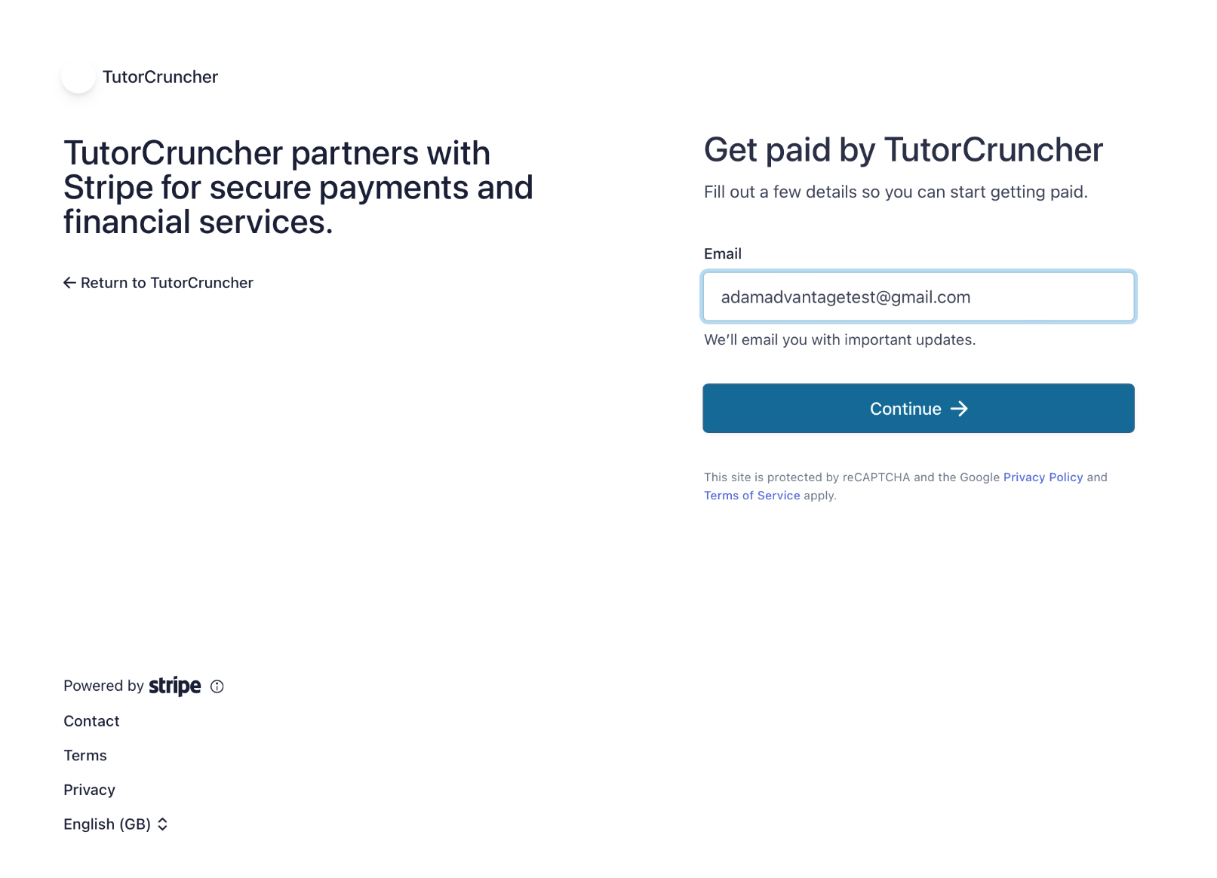

Section 5.3 - What’s a chargeback and how do I deal with it?

A chargeback is a charge that is returned to a payment card after a customer successfully disputes an item on their account statement or transactions report (In this case Invoices). If for example your client disputes a charge with their invoice, due to an additional expense not agreed upon, then a chargeback may be processed. 💳

Each chargeback request will be dealt with on a case by case basis to begin with. Academic Advantage will be contacted and you will be asked to submit supporting evidence to us within 6 weeks to prove the charge was legitimate. If a tutor gets repeated chargebacks we reserve the right to investigate this and suspend your account. ❌

Section 6 - Requesting a DBS check

Section 6.1 - How do I request a DBS check from the Government?

If you haven’t already got a DBS check you'll need to follow the next steps within this section.👇

You can acquire a background check online using the UK Government website. A background check is unconditional for us at Academic Advantage.

All you need to apply for this check is:

1) Your National Insurance Number
2) Your passport
3) Your Drivers Licence
4) Records of addresses lived in the past 5 years.

Firstly, here is the link to the government website which allows you to apply for a basic DBS check: https://www.gov.uk/request-copy-criminal-record.

A really useful guide the Government have provided can be found here: https://assets.publishing.service.gov.uk/government/uploads/system/uploads/attachment_data/file/1059974/Quick_Guide_to_DBS_Checks.pdf.

If you would like to work with Academic Advantage we have an extremely strict entry criteria, one of these is that all tutors must hold at minimum a standard DBS check (£18), however we recommend that all tutors obtain an enhanced check (£38), these do cost more but tutors with these are in a much higher demand as parents have the greatest reassurance possible. The check will typically take around 2 weeks. 🤝

Section 6.2 - How to request a DBS another way

A Responsible Organisation (RO) is an organisation registered with the DBS to submit basic checks through a web service. A RO will capture the details of a basic check application in their system, before transferring it to DBS via a web service. You can apply for DBS basic checks by visiting the website of a Responsible Organisation. ✅

If you would like to go through an RO then follow the link giving you a list of companies to choose from: https://www.gov.uk/guidance/responsible-organisations

Section 7 - Additional Support

Section 7.1 - What do I need to do before a session?

It is vital that you have a secure internet connection that is consistently strong. While we appreciate that there is always the possibility that connections will be unstable, you should only be delivering sessions from a place you know to be consistently reliable. 📡

You will need to make sure that you are present for the start of any session. We advise being online five minutes prior to starting the session so that you can greet any pupils who arrive early, though we do appreciate that this will not be possible if you are teaching back-to-back sessions. In this case, it is fine to finish the earlier session one or two minutes prior to beginning the following one so that you are there for a prompt start. ⏲️

Section 7.2 - Where can I complete a session?

As this is a completely remote role your background needs to be considered. You should have the option to blur your background slightly or to add an appropriate background. Please consider the background so that it suits the context of learning. If you do have items on show in the background (e.g. books, paintings, photographs), please ensure that none of the items are likely to cause offence or are age inappropriate. 🙅‍♂️

You must also make sure that you are in an appropriate place to deliver the sessions. It should be a quiet space where you are unlikely to be disturbed and lighting should be appropriate so that pupils can see you on your screen clearly. 🔕

Please ensure you have tested this beforehand so that your face and immediate surroundings are clearly visible and that it is not too dark or obscured by any glare from sunlight. 🌞

Section 7.3 - Sending additional learning materials or links

Links you share with your pupils should be checked thoroughly before being viewed so that you are sure that the content is appropriate for the pupils watching. Please also remember that if a link contains adverts, these should be checked and skipped where this is possible. If the advert cannot be skipped or removed and contains any inappropriate material, do not show the link.🙅‍♀

Section 7.4 - Where do Academic Advantage fees go?

The fees that Academic Advantage charges Clients go to several key parts of our business. These are as follows:

- Finding new Clients (Parents & Schools) and connecting them with you, arguably the most important in the eyes of a tutor. We do all of the marketing for Academic Advantage so that you don’t have to worry about ever not having a Client using your services. We have a marketing team whose aim is to help us stand out and help us become the best tutoring platform in the UK.

- Upgrading our platform for our Tutors and Clients to make the process of finding a tutor quick and simple while providing a high quality learning experience for both parties.

- Support teams for both Tutors and Clients to help with any rescheduling, technology problems, and much more.

- Recruiting Tutors so we can help thousands of students across the UK. We recruit, select and train our Tutors to maintain a high quality service on our site.

- Making lessons safe & compliant. Our Safeguarding and Legal teams are vital in making sure every student and tutor enjoys a safe and legally compliant learning experience. This includes DBS disbursements, safeguarding checks and vetting.

- Providing direct support for any questions or problems you may have. We know that more often than not this is your primary job and you have experience, but sometimes it's helpful to just have someone there when you do on the off chance need them to support you.

- Sorting your pay. Traditionally tutors would have to invoice every customer on a monthly basis, which would involve paperwork, admin, and often chasing and checking multiple payments. Our Finance team sorts all of this out for you.

Section 7.5 - Who can I contact for further support?
Send us an email on info@academicadvantage.co.uk and we will get back to you. Feel free to also message Claire Shoreland on Linkedin who is responsible for onboarding our Tutors. 🙌

Congratulations and good luck from the team here at Academic Advantage, we can’t wait to begin working with you.

