Academic Advantage

A Beginner’s Guide for Clients and Students



Updated - August 2023

Key Personnel at Academic Advantage:

Clare Shoreland - Client Relations Manager

James Farrelly - Director of Education

Harriet Pearson - Operations Manager

Louis Burton - Business Development

Table of Contents

Section 1 - Your Profile 3
Section 1.1 - How do I create an account? 3
Section 1.2 - Summary of the Sign-Up process 4
Section 1.3 - Registering My Child and Child Login 5
Section 1.4 - Resetting My Password 6
Section 2 - Booking 7
Section 2.1 - Booking a lesson 7
Section 2.2 - Free Trial Lesson 8
Section 2.3 - Cancelling a booking 9
Section 3 - Lessons 10
Section 3.1 - Viewing Lessons 10
Section 3.2 - Joining my Lesson 11
Section 3.3 - Using the Online Classroom 12
Section 3.4 - Technical Difficulties 13
Section 3.5 - Lesson Recordings 14
Section 3.6 - Viewing Lesson Reports 15
Section 3.7 - Uploading documents 15
Section 3.8 - Reporting a problem 16
Section 4 - Payment 16
Section 4.1 - Adding Payment Details 16
Section 4.2 - Paying Your Tutor 16
Section 4.3 - Disputing an incorrect invoice 18
Section 5 - Additional support 18
Section 5.1 - Who can I contact for further support? 18

Section 1 - Your Profile

Section 1.1 - How do I create an account?

If you haven’t already, create an account with Academic Advantage by clicking the link below:

https://secure.tutorcruncher.com/academic-advantage/signup/client/

Enter your details as requested, this will take you to our online platform where you can create your profile, book tutors and undertake lessons. 💼
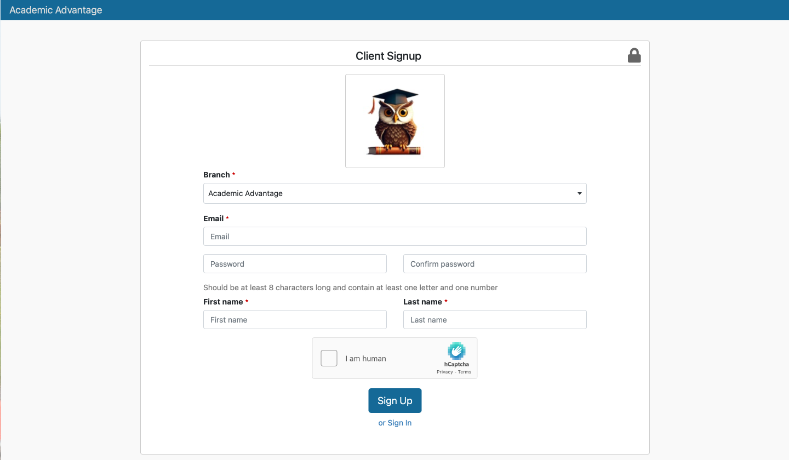

Section 1.2 - Summary of the Sign-Up process
Once you've completed the signup process and confirmed your email address along with agreeing to our terms and conditions, you'll gain full access to our website. Your first destination will be the dashboard, where you can manage your profile. Look for the blue edit button located under your profile picture to make any necessary changes. ⚙️

Note:

- Parents should provide their own information in this section; do not enter your child's details here. For the child's information, please proceed to the student profile tab. Additional information about registering your child can be found in Section 1.3

- If you're signing up to enrol for lessons (and not as a parent), you'll need to create a student profile in the left-hand 'Student Profile' tab. This step is crucial for you to be able to book lessons effectively. Also see Section 1.3

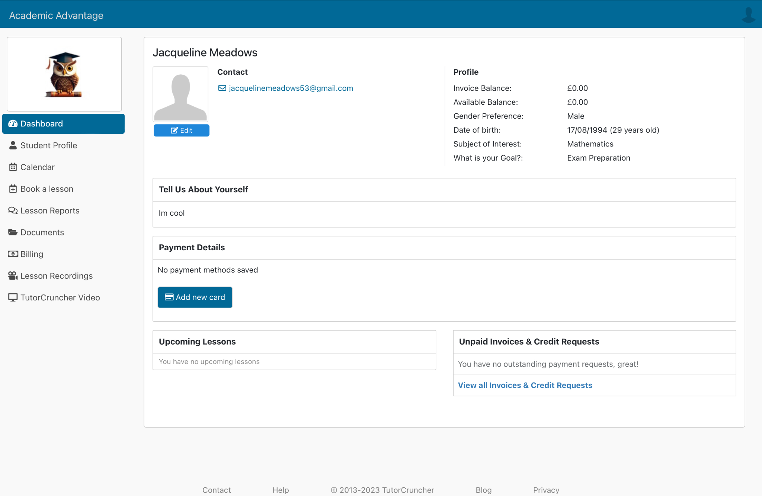

Section 1.3 - Registering My Child and Child Login

To register either yourself or your child on our platform, follow these steps:

- Navigate to the student profile tab in the left-hand menu.

- To add your child, click Create New Student Profile/Child's Profile and provide all the relevant details. Don't forget to include your child's email address. A link will be sent to them, allowing them to set up their own student account. The Student/Child will need to follow the link, create their password and accept the terms and conditions before an account can be made.

Please note that the student account is more limited in comparison to the initial account you create. In their student account, your child can access their calendar, join lessons, and view documents and reports. 💻

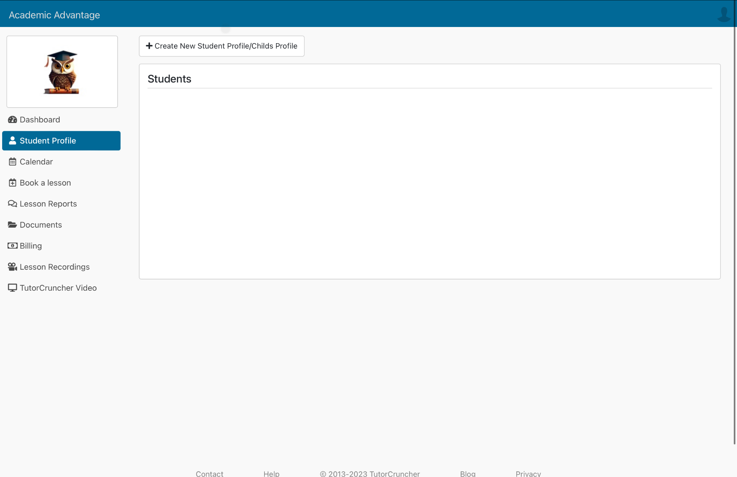
Note: You have the option to add multiple children! 👨‍👦‍👦

Section 1.4 - Resetting My Password

If you have forgotten your password you can easily reset it by going to the Login Screen (https://secure.tutorcruncher.com/academic-advantage/login/) and selecting Reset Password below the password text box. This will send you a password reset email to your email address. 📧
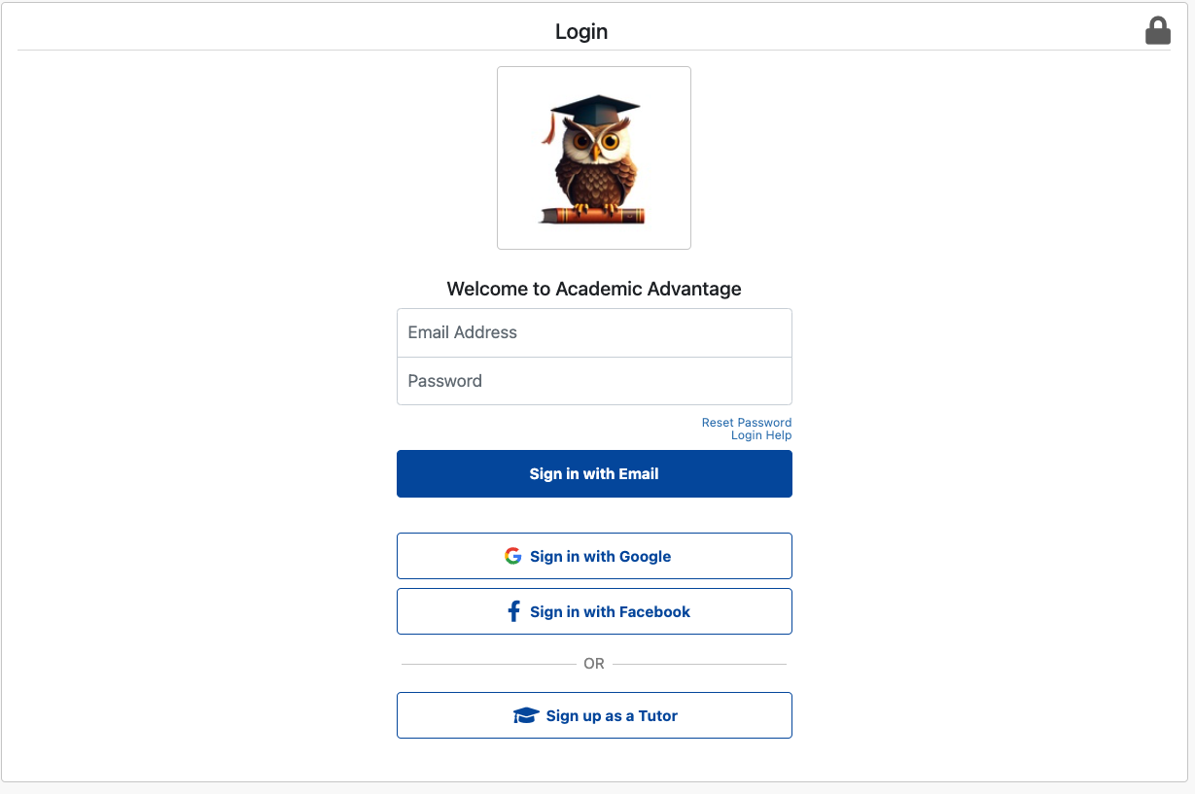

Alternatively, if you want to change your password inside our platform then you can find this when editing your profile in the top left under Change password 🔐

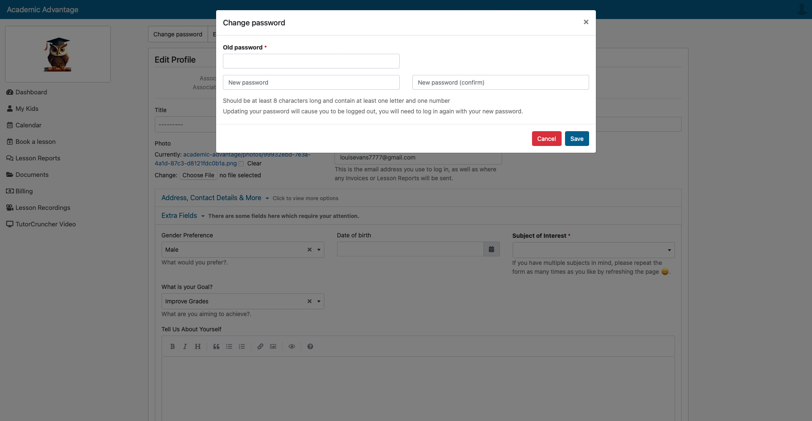

Section 2 - Booking

Section 2.1 - Booking a lesson

🖥️How to Book:

To book a lesson, navigate to the Book a Lesson tab on the left hand side. A list of available tutors will be displayed, allowing you to filter them by subject. Once you've chosen your preferred tutor, click Book Lesson, and the tutor's availability will be shown. 🧑‍🏫

✅Confirmation:
Choose your teaching level, confirm your booking, and await your tutor's response to either accept or decline your request. You will receive a notification via email. 📧

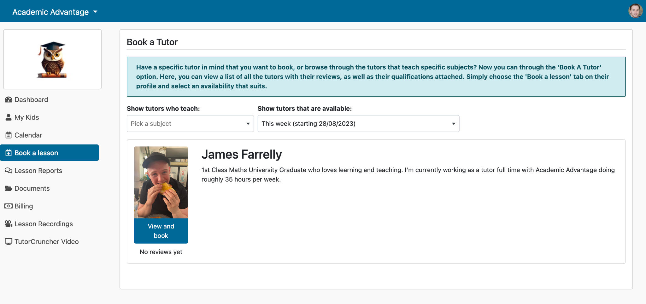

Section 2.2 - Free Trial Lesson

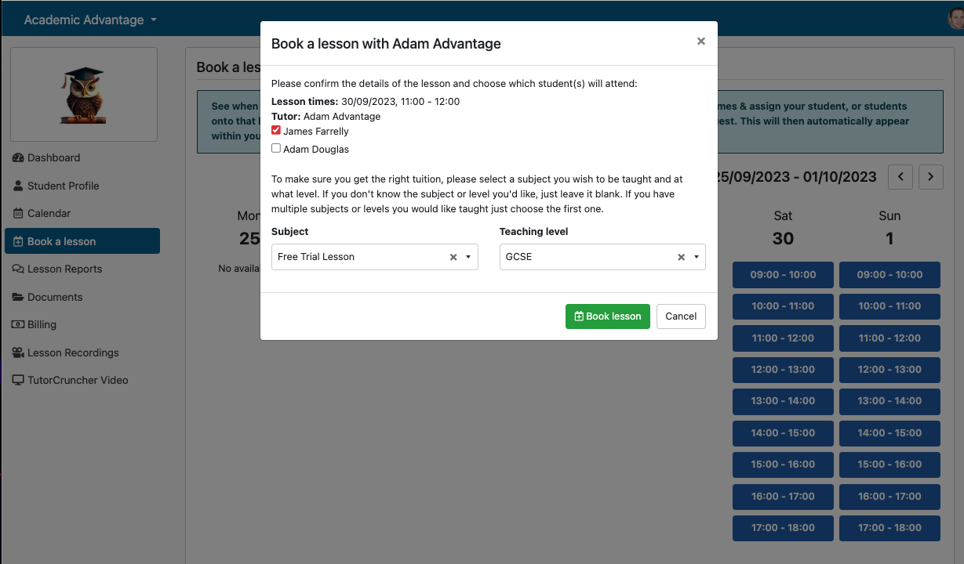
To book a free trial lesson, select the Free Trial Lesson under the subject selection field. Select your required teaching level, and wait for your tutor to accept your request.

Section 2.3 - Cancelling a booking

✏️Editing a booking:

Unfortunately there is no option to edit a booking once it has been confirmed. You will have to cancel the booking and book again.

❌Cancelling a booking:

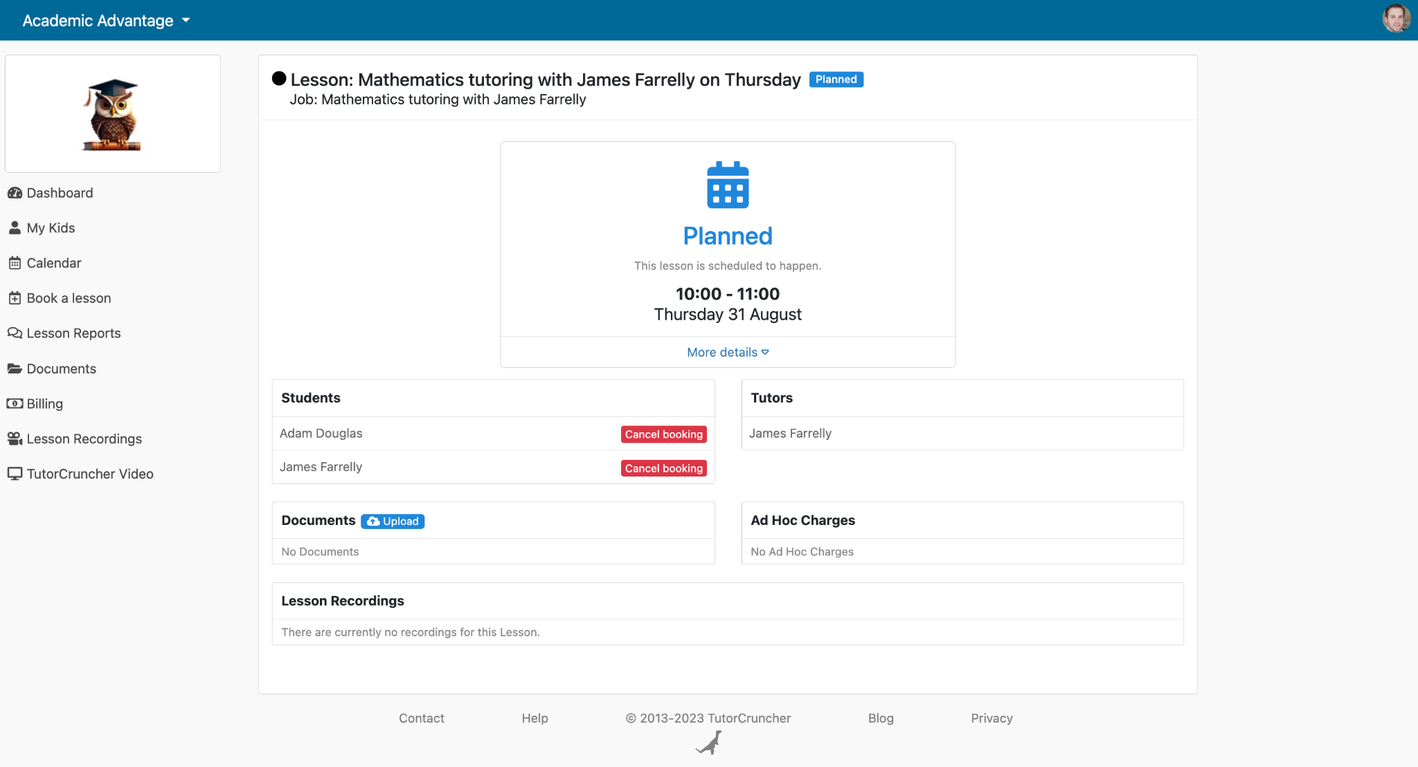
To cancel a booking, go to the relevant lesson and select the red Cancel Booking in the students section.
Section 2.4 - Cancellation Policy

If you cancel a lesson more than 10 hours before the scheduled time, you are not eligible to pay. ✅

However, if you cancel within 10 hours of the scheduled time or do not show up for the lesson, you are liable for the payment of 50% of the Tutor Fee and the full amount of Platform Fee. ❌

Section 3 - Lessons

In the left hand menu you are able to navigate to different sections of your profile, where you can view all information related to your upcoming tuition, available lessons and your children’s reports.

Section 3.1 - Viewing Lessons

In the Calendar tab, you can view your upcoming lessons in both yours and your child's account.

You can click on each of these appointments to see more detailed information. 🖱️

You can also find a list of upcoming lessons in your dashboard.
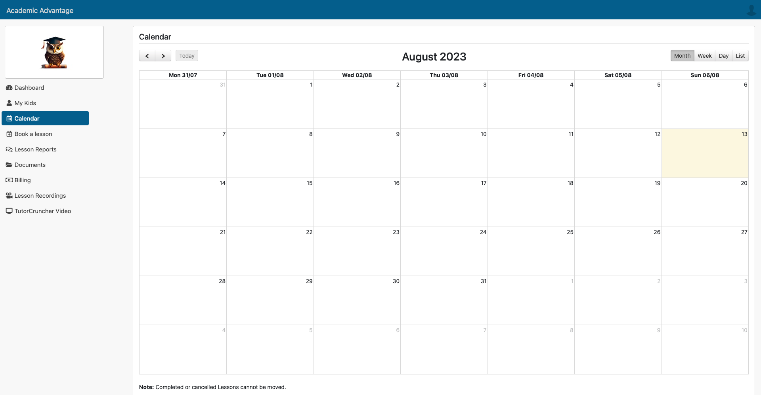

Section 3.2 - Joining my Lesson

You can join your lesson from both your main account and your child's account.

To join your upcoming lesson you need to navigate to the Lessons tab in the left hand menu and select the name of the lesson with your tutor. Now select your lesson and you will be taken to a Lesson detail screen. From here you can then select the Blue “Join your lesson with TutorCruncher Video now”. 🖥️

Note
- Ensure all relevant documents required for the session are uploaded.
- Make sure to join the session at least 5 minutes before to avoid any delays!
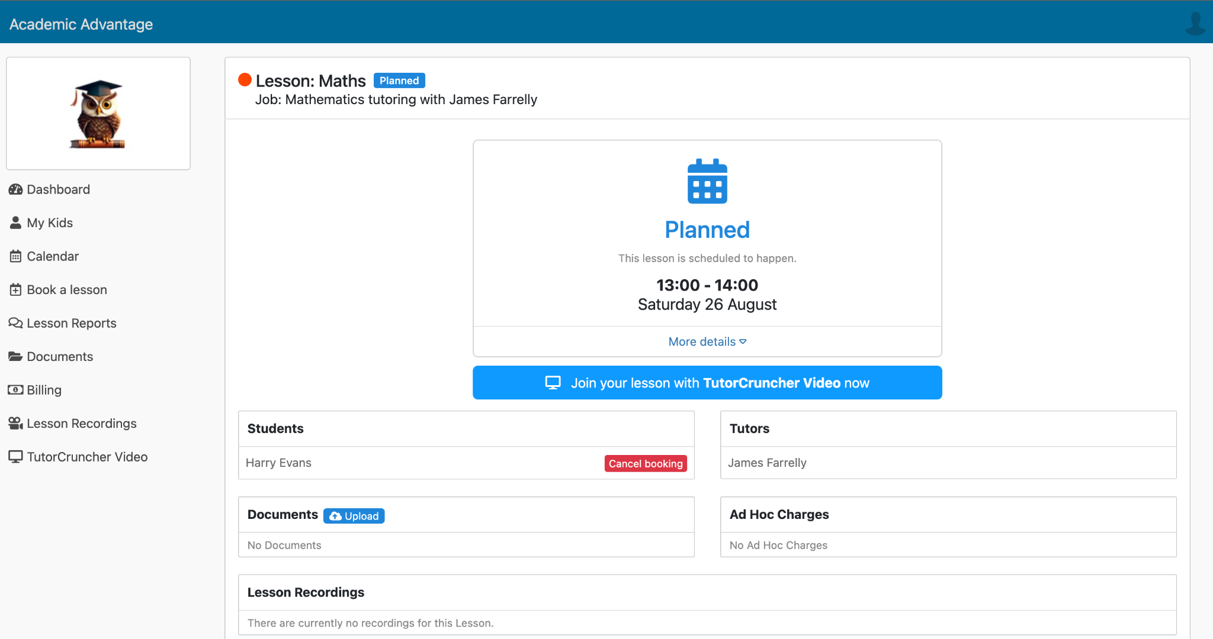

Section 3.3 - Using the Online Classroom
Once you’ve clicked to join your lesson you will be asked to allow access to your camera and microphone, click yes and make sure both of these are working within the 5 minutes before your lesson starts. 🎤

Note: Make sure you enter your name so it’s not displayed as a guest!

In the bottom bar, you can access the camera, mute, view the students in your room, access chat, and share your screen! 🖥️

You can access the settings in the top left hand corner using the cog button to change your microphone and more. ⚙️
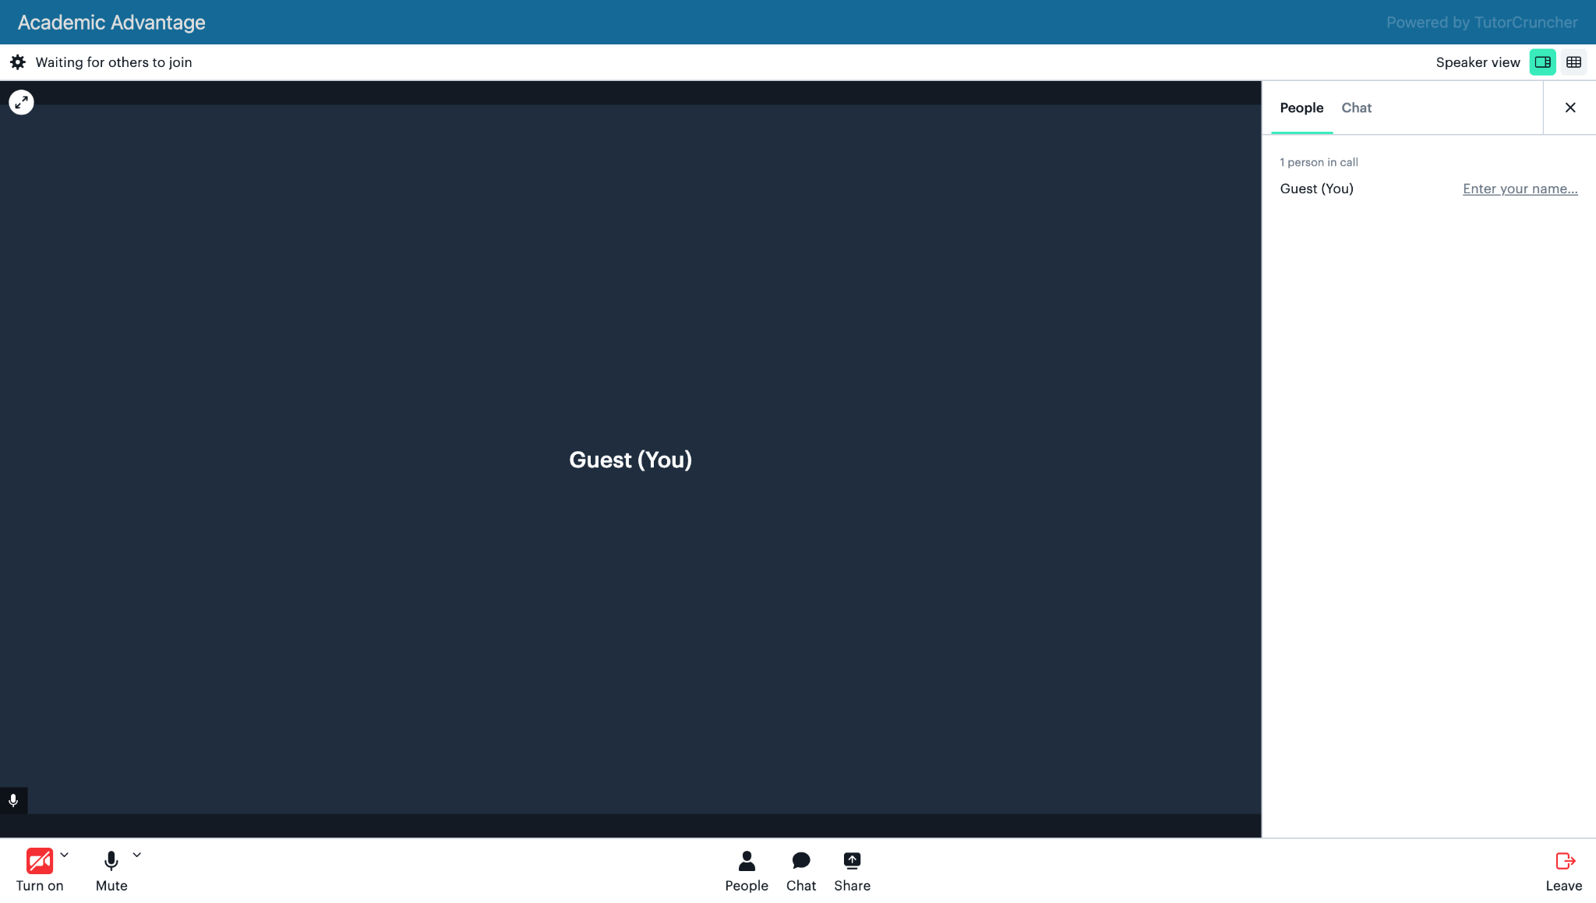

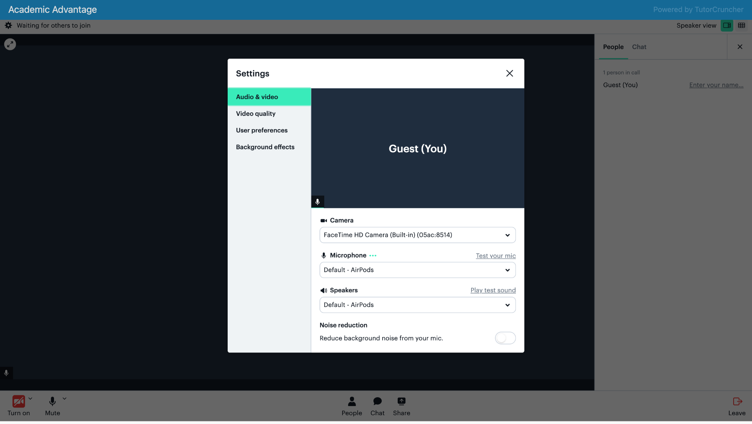

Section 3.4 - Technical Difficulties
Encountering technical difficulties during an online lesson? 😢

Don't worry - we're here to help! Here are some troubleshooting steps you can take if you experience technical issues during your lesson on Academic Advantage:

📡 Bad connection:

If you're experiencing connection problems, it may be related to your own connection or that of the person you're in a lesson with. We recommend checking the speed of your internet connection. If you have a bad WiFi connection, you can try switching to an ethernet cable if you're using a computer, or using 4G/5G mobile data hotspot.

🌐 Browser problems:

Access to the camera is possible from different browsers, but there may be compatibility issues with Google Chrome on certain versions of Windows. If this is the case, we recommend using Mozilla Firefox instead.

Tip 1: Change permissions from your Google Chrome browser:
- Go to your Google Chrome browser.
- Click on the three dots icon in the top right-hand corner.
- Click on Settings.
- Click on Privacy & Security.
- Click on Site settings.
- Select Camera or Microphone and check that your camera or microphone is authorised, and that Academic Advantage is not listed in sites blocked by your browser.
Tip 2: Change permissions in your computer's Windows settings:
- Go to Windows settings.
- Go to Privacy.
- Verify that camera access for the device is enabled.
- Enable the option Allow applications to access the camera.
- In the Choose which Microsoft Store apps can access the camera section, enable Windows Search, Camera, and App Connector.
- For the microphone, follow the same steps.

If you've tried these steps and are still experiencing technical difficulties, don't hesitate to contact us for further assistance. Our support team is always here to help you get the most out of your online tutoring experience. 👏

Section 3.5 - Lesson Recordings
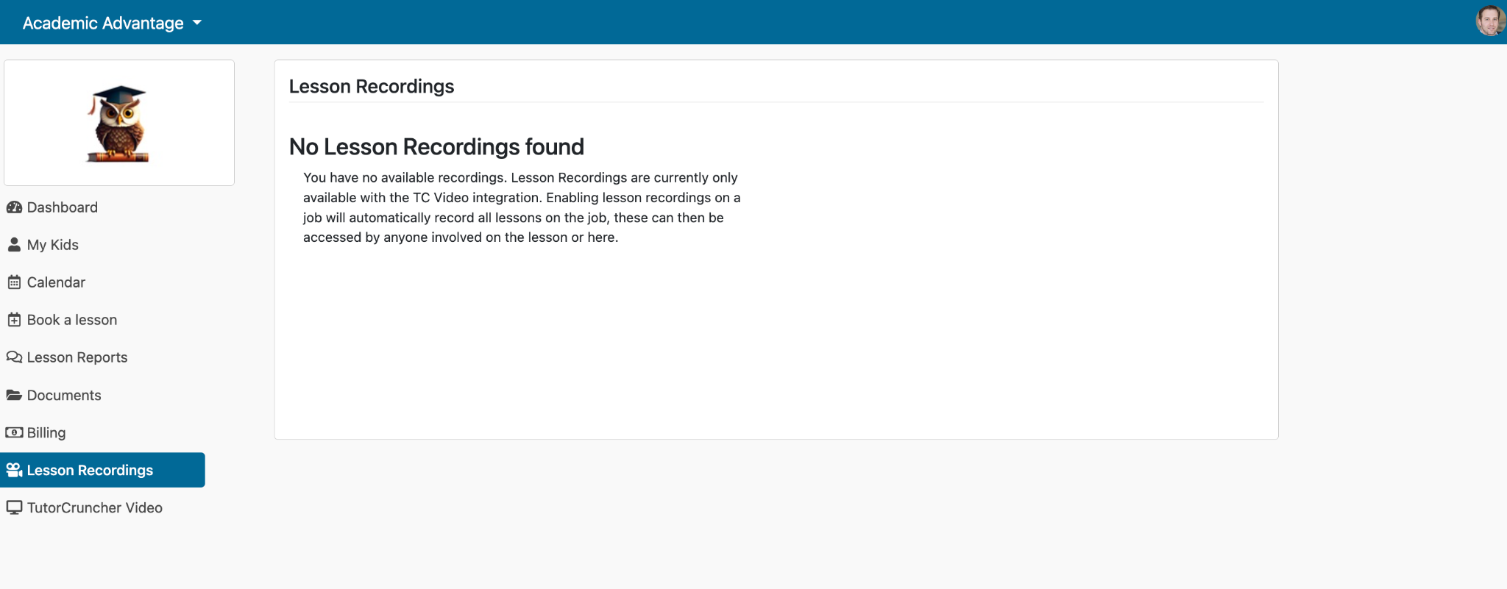
You can find your lesson recordings in the left hand tab under Lesson Recordings. Once your lesson has finished you will be able to view the full recording here.

Section 3.6 - Viewing Lesson Reports
Lesson reports can be viewed on your client dashboard, alternatively you can also navigate to the Lesson Reports section of the left hand menu.
Note: Your child can also access Reports in their student account. 📝
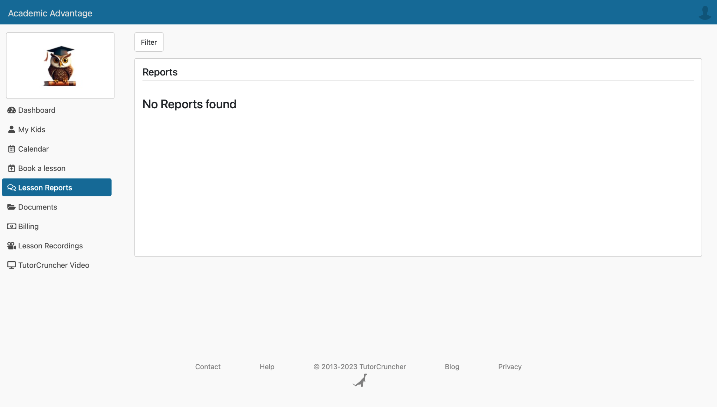

Section 3.7 - Uploading documents
The documents tab on the left hand menu is used to see all the relevant documentation that has been shared with you by your tutors or admins, and will also show the documents you have uploaded. Typically, these documents will be worksheets, teaching resources and homework 📝
You can upload documents through the left hand tab, or directly into a specific lesson under the documents tab.

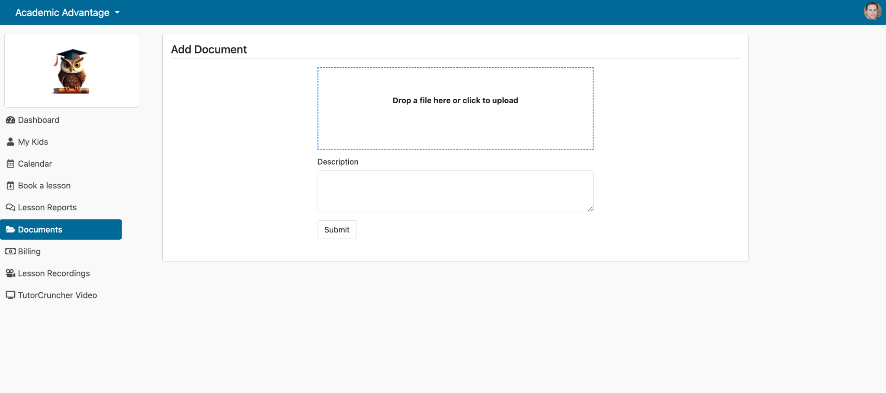

Section 3.8 - Reporting a problem
If you have encountered any problems with your lesson, or any issues with your tutor. Please contact us at info@academicadvantage.co.uk or message Claire Shoreland and or Harriet Pearson on Linkedin.

Section 4 - Payment

Section 4.1 - Adding Payment Details
You can input your payment details within your dashboard by navigating to Payment Details. This section allows you to add multiple cards and make changes to your payment information as needed. 💳

Section 4.2 - Paying Your Tutor
Note: Payment will always be taken after your session!
After your session has been marked as complete by your tutor you will automatically be sent an invoice. This will be sent via email, but can also be found in the Billing tab on the left hand side. 🏛

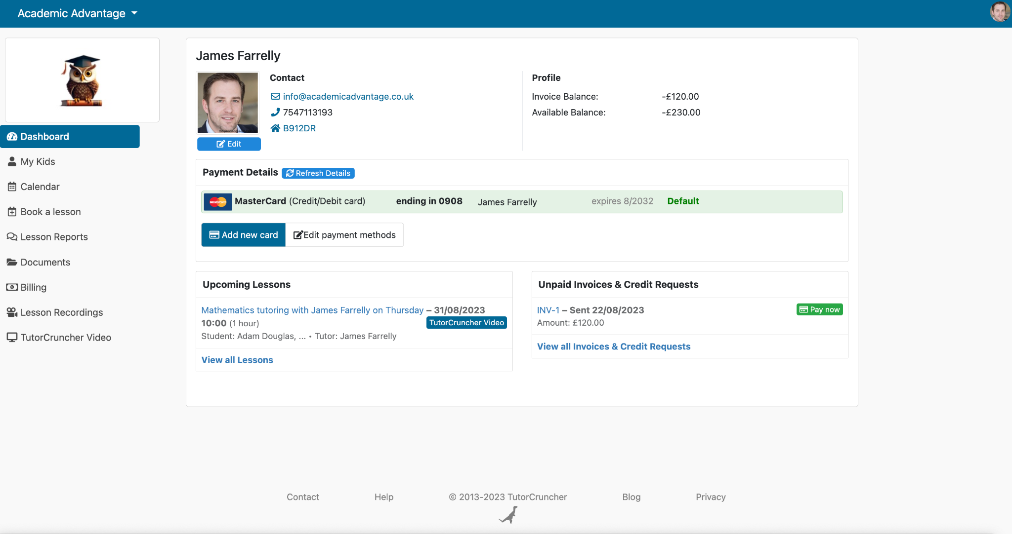

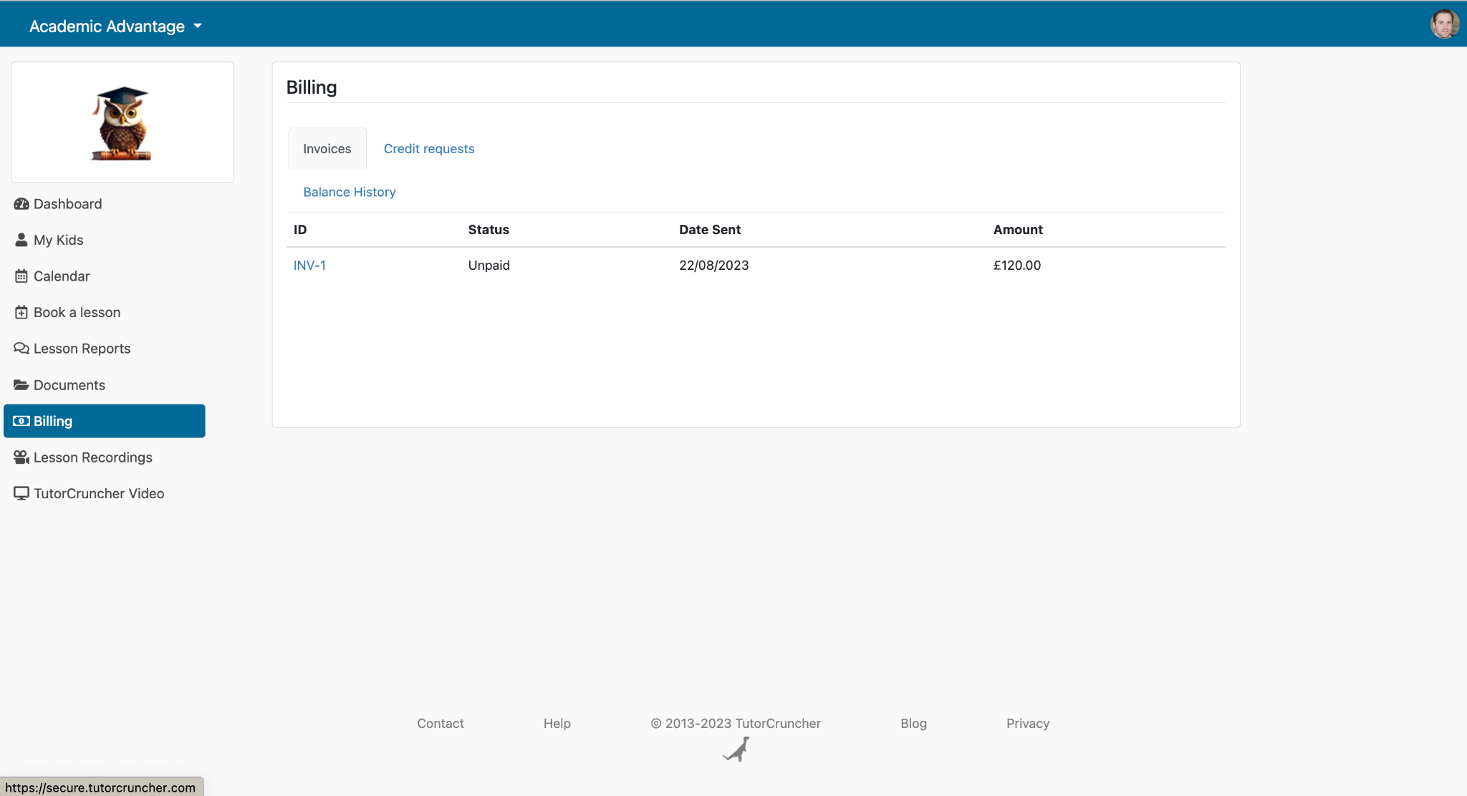
We will automatically charge your card 1 day after the invoice has been raised, but you can also pay directly through the Billing tab, or the Unpaid Invoices & Credit Requests section on your dashboard. 🧾

Section 4.3 - Disputing an incorrect invoice
If you believe you have been incorrectly invoiced, including any additional charges not related to your session, please don't hesitate to contact us as soon as possible via email at:

info@academicadvantage.co.uk

We sincerely apologise for any inconvenience this may have caused.

Section 5 - Additional support

Section 5.1 - Who can I contact for further support?

Need some further support? Send us an email on info@academicadvantage.co.uk and we will get back to you. Feel free to also message Claire Shoreland on Linkedin who is responsible for Client relationships. 🙌

Thank you once again for trusting the team here at Academic Advantage, we can’t wait to begin supporting your educational journey.

